# PRJ566 – Summer 2020

# PRJ566 – Team No: 1

# Name of Project:  NurseEllie

# Project Leader: Vivian Chiu

**Last updated:** Monday, July 6, 2020

**Team Members:**

**1.** Vivian Chiu

**2.** Daniel Park

**3.** Vu Pham

**4.** Steven Tran

# TABLE OF CONTENTS

1. **Introduction/Overview - Document Information**
   1. **Document Authors**
   2. **Revision History**
   3. **Document Conventions**
   4. **Document Purpose**
   5. **Intended Audience**
   6. **Acronyms & References**
   7. **Group Agreement**
2. **Project Overview**
   1. **Project Proposal**
   2. **Project Detailed Scope & Functionality**
   3. **Stakeholders and Users**
   4. **Business Opportunity**
   5. **Risks**
   6. **Constraints**
   7. **Operating Environment**
   8. **Operational, Performance & Security Requirements**
3. **Process & Data Modeling**
   1. **Business Rules**
   2. **UML/DFD Modeling & Data Modeling**
   3. **Interface Mock-ups**
4. **Database**
   1. **Scripts to create, populate, delete tables**
      1. **Scripts to create tables**
      2. **Scripts to populate tables**
      3. **Scripts to delete tables**
   2. **Data Dictionary**
   3. **ERD**
5. **Implementation Schedule**
   1. **Work Breakdown Structure**
   2. **Implementation Schedule for PRJ666 - using Microsoft Project**
6. **Measurable deliverables**
7. **Acceptance Criteria**
8. **Risks and Response**
9. **Client / Faculty Sign-off**

# 1 - Introduction/Overview - Document Information

## 1.1 Document Authors

Vivian Chiu, Daniel Park, Vu Pham, Steven Tran

## 1.2 Revision History

|  |  |
| --- | --- |
| Week 03 | 1.   Introduction/Overview  1.1  Document Authors [Completed]  1.6 Acronyms & References [Updated]  1.7 Group Agreement [Completed]  2.1 Project Proposal [Completed] - Added project background, executive summary, problem statement. |
| Week 04 | 2.2 Project Detailed Scope & Functionality [Completed]  2.3 Stakeholders & Users [Completed]  2.4 Business Opportunity [Completed]  1.6 Acronyms & References [Updated] |
| Week 05 | 2.1 Project Proposal [Updated] – Added project objectives & boundaries  2.5 Risks [Updated]  2.6 Constraints [Completed]  3.2 UML/DFD Modeling and Data Modeling [Updated] |
| Week 06 | 2.5 Risks & Response [Completed]  3.2. UML/DFD Modeling & Data Modeling [Updated]  3.3 Interface Mock-ups [Updated] |
| Week 07 | 2.1 Project Proposal [Updated] – updated scope and target audience  2.2 Project Detailed Scope & Functionality [Updated] - Security requirements updated |
| Week 08 |  |
| Week 09 |  |
| Week 10 |  |
| Week 11 |  |
| Week 12 |  |
| Week 13 |  |
| Final |  |

## 1.3 Document Conventions

* Any text highlighted in red indicates an exception or error
* Anything highlighted in blue is in-progress
* Any text highlighted in yellow is an important point.
* Any text highlighted in green was recently added.
* Any text *italicized* represents definitions.

## 1.4 Document Purpose

The purpose of this document is to formally record the process the team completes NurseEllie project. This document will list the group plan (calendar, due date), resources, tasks that are assigned to each member, achievement from every week updated as well as important data and special notes for the project.

The main structure of the document is included as follows:

Part 1, Introduction: Provides a general overview of the project, identifies the Authors, outlines the regulatory context for the project, revision history, audience

and describes the purpose as well as group agreement.

Part 2, Project Description: Presents an overview of the Project Proposal, including detailed scope & functionality, stakeholders and users, opportunity and risk as well as various operating environment

considerations.

Part 3, Project Setting: Provides a summary description of the business rules. This includes components of the UML/DFD Modeling & Data Modeling. Also, it demonstratesInterface Mock-ups.

In this part, the project will be setting up by having a specific database (SQL or PostgreSQL)as well as scripts to create, populate, and delete tables.

This Document Purpose has been developed in accordance with, and contains the prescribed information set out between team members including associated guidance.

## 1.5 Intended Audience

By the time starting the project, we thought together about the difficulties and challenges for the elderly customers, so we finally agreed that our product would best support the older people whose age group in range 50-90. However, with additional external ideas and research, NurseEllie is now geared to everyone who simply having a smartphone.

## 1.6 Acronyms & References

|  |  |
| --- | --- |
| Health Literacy Statistics in Older Adults | Centers for Disease Control and Prevention. Improving Health Literacy for Older Adults: Expert Panel Report 2009. Atlanta: U.S. Department of Health and Human Services; 2009. Retrieved from: <https://www.cdc.gov/healthliteracy/pdf/olderadults-508.pdf> |
| Factors affecting Health Literacy | Ratzan, S. C., & Parker, R. M. (2000). Introduction. In C. R. Selden, M. Zorn, S. C. Ratzan, & R. M. Parker (Eds.), National library of medicine current bibliographies in medicine: Health literacy (NLM Pub. No. CBM 2000-1). Bethesda, MD: National Institutes of Health, U.S. Department of Health and Human Services. |
| Defining Health Literacy | National Network of Libraries of Medicine. (n.d.). Health Literacy. Retrieved from:  <https://nnlm.gov/initiatives/topics/health-literacy> |
| OTC medication | Over-the-counter medication. |
|  |  |
|  |  |

## 1.7 Group Agreement

**TEAM AGREEMENT**

**TEAM AGREEMENT**

**Team #:** 1

**Project Title:** NurseEllie

**Project Time Frame:** 8 months

* May 2020 - August 2020. In PRJ566 determine requirements and design system
* September 2020 - December 2020. in PRJ66 build, implement, and test system

**Team Members:** Vivian Chiu, Daniel Park, Vu Pham, Steven Tran

**Team Leadership:** Vivian Chiu

**Team Functions:**

* We will share information through MS Teams, Discord, email and meetings.
* Meet Wednesday after class to divide group work and schedule Saturday meeting if applicable.
* Meet Friday after meeting with the Professor to report progress and raise issues.
* Meet Saturday morning before major deadlines to share and review work
* Implement any changes and correct errors identified in Saturday's meeting by Sunday deadline.
* Store submittable work on MS Teams and draft work on Google Drive
* Complete agreed work for Friday meeting

**Team Meetings:**

* Wednesday: 1:30-2:00 pm. After class to assign tasks
* Friday: 1:45-2:15 pm. After meeting with the Professor
* Saturday: 10:00-11:00am. Optional meeting before major deliverables

**Team Problems:**

* Communicate openly and get all team members viewpoints to recognize cause of issue
* Gather possible solutions as team, find points of agreement, and then arrive at consensus
* Create plan of action based on agreed solution which includes responsibilities and timelines
* If issues, deviations, or problems are serious then inform professor
* If consensus cannot be reached consult as team with professor
* Team members can approach the Professor to request member removed from the team when:
  + Team member continually fails to meet responsibilities (attend meetings, respond to communications, complete work on time)
  + Is abusive toward others

**Team Commitment**

The undersigned members agree to work together on the project until the end of the PRJ666 next Semester.  They recognize that as a team and individually they are responsible for the quality of all deliverables.

|  |  |
| --- | --- |
| **Name** | **Date** |
| Vivian Chiu | June 3rd, 2020 |
| Daniel Park | June 3rd, 2020 |
| Vu Pham | June 3rd, 2020 |
| Steven Tran | June 3rd, 2020 |



# 2 - Project Overview

## 2.1 Project Proposal

**Project Background**

The NurseEllie project is an e-health web/mobile application that is designed to help individuals around the ages of 65 years or younger to ensure their prescription consumption needs are met. Alternatively, it can be used as a tool for caregivers to keep track of their dependent’s required medications. NurseEllie is a plausible project because it is targeting a demographic that is known for having health literacy below the basic level which can lead to health issues to arise if instructions are not well communicated between the patient and the practitioner/physician. The app will have a handful of features that combats the barriers to health literacy and, connects patients or caregivers to their health professional to promote patient-centered care.

**Executive Summary**

NurseEllie's vision is to help patients adhere to their medication regimen, and for health professionals to understand their patient’s feedback using technology. Its purpose is to close the health literacy disparity for at-risk individuals and reduce the barriers to developing a good patient-physician relationship. Features of the app will be designed to be user friendly, easy to learn, accessible, and promotes health literacy.

**Problem Statement**

|  |  |
| --- | --- |
| **The Problem of:** | Patients lack health literacy for correct medication intake adherence, and health professionals need a way to understand if a patient is taking their medication. |
| **Affects:** | The patients that are not following correct prescription instructions can encounter health issues or life-threatening problems, or health professionals do not have insight to their patient’s recovery after an appointment |
| **The impact of which is:** | Increased health complications due to incorrect medication consumption,  Lack of communication between a patient and their health professional |
| **A successful solution would:** | A user-friendly app that assists patients to follow their medication regimen responsibly and safely and allow them to communicate with their health professional. |

**Product Vision**

|  |  |
| --- | --- |
| **For** | At-risk individuals taking medication, health professionals and caregivers |
| **Who** | Have difficulty adhering or keeping track of their medication regimen and understanding their medication |
| **NurseEllie** | Is an Android, iOS, web health services application |
| **That** | gives health care providers ability to manage patient’s medication regimen remotely as well as receive and provide real-time feedback |
| **Unlike** | Pill Reminder & Medication Tracker - Medisafe |
| **Our product** | features integrated voice, video and chat communication, remote scheduling, feedback and automated reporting |

## 2.2 Project Detailed Scope & Functionality

## 

**Project Goal and Objectives:**

The project will leverage technology which is easily accessible to all individuals to deliver health information, increase adherence to medication prescriptions and increase accessibility to health services.

Overview of the Project Goals:

* Provide easily digestible information about the medication
* Allow health professionals to monitor patient’s medication intake in real time
* Allow patients to provide feedback on symptoms resulting from medication, blood-glucose monitoring and external clinic visitations
* Provide accessible virtual appointments
* Increase patient - health professional relationship

**Phase I - Minimum viable product (MVP)**

Phase I minimum viable product elements are defined as core essential core requirements and features of the app. They are highlighted in the functional requirements, non-functional requirements, project scope, and success criteria. They are expected to be implemented within the project time frame’s December deadline. However, features that are not highlighted are potential components that that may be added within the project time frame, time permitting.

**Functional Requirements**

1. Manage basic user information
   * User creates account and profile
   * Health professional validates or registers patient
   * Health professional pays for app subscription
2. Manage medication regime
   * Health professional adds/deletes prescription medication to/from patient’s regime
   * User can add off-the-counter medication to their regime
   * User can view list of current medications
   * User views information on medication
   * User sets medication intake reminder schedule
   * User responds to medication intake alert/reminder
3. Record patient feedback
   * Patient performs symptom check
   * User views missed, late and on-time medication intake
   * User shared medication log
4. Record patient blood-glucose
   * Patient shares result of at-home blood-glucose monitor data
5. Provide emergency support
   * User views map of closest medical emergency clinics or hospitals
   * User reports visitation to hospital or alternative clinics

**Non-Functional Requirements**

1. Operational Requirements
   * The application should be accessible on Android, iOS.
   * The application should be built using React Native Framework for Android and iOS
   * The application will be portable with the same functionality and layout on all Android and iOS devices
2. Security Requirements
   * Only can set a user’s prescription medication
   * Acquiring consent of the user before any information is transmitted between the patient or user to another account holder
   * Local application files are stored encrypted on the device and deleted upon uninstallation
   * Session time limit for a logged in user for a certain amount of minutes/hour.

**Details of Features**

NurseEllie is an e-health application which provides a subscription-based service for health professionals to use to connect with their patients. Health professionals will be able to register patients or have patients connect via a health professional QR Code to allow the patient to connect directly to the health professional through the app.

In turn, the health professional would be allowed to manage the patient’s medication regime: add or deleting prescription medications and specify dosages, setting alerts or reminders for patients. The health professional will automatically receive information about the user’s medication intake after the alert or reminder is dismissed, or when the user completes a symptom checklist or survey. The user can also choose to send blood-glucose monitoring information, if they have an at-home monitoring device. The application will also allow the user to request or confirm a virtual appointment. The application also allows a user to report a visitation to an alternate clinic to their health professional.

Anyone can make an account and utilize NurseEllie’s basic features including setting alerts and reminders for over-the-counter medication, view photo-dictionary information of their medication along with possible side effects and recommended dosages, access to side-effect symptoms checklist to monitor their reaction to the medication, and view a map of closest emergency medical clinics.

**Project Boundaries**

**Within Scope:**

* + A static web/ phone app with open access for registered users
  + Used by the general public
  + Support for Android, iOS
  + A program for handling login and logout for existing patients as well as creates new accounts for users
  + A program for the patient or a health professional to enter, modify, or delete a medication and intake regime
  + A program for setting up a health professional ready to meet all schedule requirements from patients
  + A program to review and inform the health professionals about Symptom Checklist, patient medication adherence, blood-glucose monitoring result of the case they are responsible for
  + An administration system for handling any external service.

**Out of Scope:**

* + Support for any other aspect than health such as financial or education
  + The ability to handle complex inquiries, such as schedule appointments with a specific doctor in real life.
  + The ability to handle all the authorization and data protection.

**Project Deliverables:**

**Success Criteria:**

* + Patients can successfully understand information regarding their prescriptions.
  + Real time monitoring of patient’s medication consumption by health professionals.
  + Enhanced one to one relationship between patient and health professional.
  + Patients can give feedback on:
    - Symptoms from outcome of medication
    - Medication intake
    - Blood-glucose monitoring
    - External clinic visits
  + Patient/Health professionals can easily contact one another through virtual appointments.
  + NurseEllie app operates successfully across 94% or more mobile platforms.

**Project Assumptions:**

* The user is responsible for downloading the installing the application
* The patient will be able to navigate the application on their own or with the help of a health professional
* The system will not require any customization between health professionals
* Team members can learn and apply new technologies
* Team members available to work 10 hours minimum per week on work packages.
* Cost of necessary technologies and services does not exceed minimal budget.

## 2.3 Stakeholders and Users

|  |  |
| --- | --- |
| **Stakeholder Name/Identifier** | **Category** |
| CEO (Chief Executive Officer) | Administration, Sponsor |
| Investors | Sponsor |
| Marketing staff | Developers |
| Project Leader | Developers |
| Developers | Developers |
| Systems Analysts | Developers |
| Operations staff | Developers |
| Test Analysts and QA | Developers |
| Implementation staff | Developers |
| Maintenance staff | Developers |
| College of Physicians and Surgeons of Ontario | Authority |
| Federation of Medical Regulatory Authorities of Canada | Authority |
| Health Canada | Authority |
| Health Professionals | Customer, User |
| Personal Support Workers (PSWs) | Customer, User |
| Administrative Assistants | Customer, User |
| Patients | User |
| Individuals taking medication | User |
| Family members | User |
| Mobile Devices, Desktop Devices | Non-Human User |

## 2.4 Business Opportunity

NurseEllie has been approached by Poromedic, who are seeking to manage and strengthen the communications between health professionals and their patients in hopes of increasing medication regime adherence. In addition, they require tele-health and mobile communication-based features to remind patients to take their medication and allow health professionals to manage patient medication activity.

Currently, health professionals at Poromedic have in-person meetings with patients to log medication intake or, health professionals assign medication and assume patient is taking the medication as prescribed. Paramed requires an electronic medium which allows recording and sharing of medication intake without in-person meetings.

NurseEllie is a medium which health professionals and patients can collaborate to improve their health. This allows patients to become an active participant in their own treatment. NurseEllie provides a way for patients to communicate and provide feedback to health professionals without in-person visitation to improve patient care.

## 2.5 Risks

|  |  |
| --- | --- |
| **Risk** | **Response** |
| Team does not currently have the experience with certain technologies to implement features including blood-glucose monitoring, virtual appointments | The whole team will meet twice a week to complete video tutorials together about how to implement blood-glucose monitoring, virtual appointments |
| Team does not currently have experience with implementing desired features on React Native | Hold team sessions to go over the health technology that is needed and how to initialize an package in React for app developing and testing |
| Success criteria for several project objectives can’t be confirmed until several months after the professes and systems are operational. | The team will keep track on the task doing during the project and make sure it meets success criteria by checking any unclear information.  Confirm the process with professor to ensure tasks that team members are doing is correct  Keep on review and testing product to ensure success criteria is confirmed |
| Patients may not support the project because not all patients feel the need to share their personal activity with their health professional. | The team will apply the necessary marketing methods such as propaganda about the need to monitor health and the benefits that the app gives users to protect their health through websites, social networking pages. |
| Project may be subjected to restrict security criterion due to handling sensitive information and will require additional security resources. | The whole team will try to discuss the most feasible methods and simple at the same time but still ensure the security for users.  Implement various security measures that do not reduce complexity but also increase security |

## 2.6 Constraints

* Budget is $0.00 (and potentially a blood-glucose machine)
* Project execution completion before December 11th, 2020 when Fall Semester Ends

## 2.7 Operating Environment

* React Native single JS codebase for android and iOS for cross-platform development
* Team members work from home on iOS and PC to code, test, and debug for iOS and Android.
* Visual Studio Code free license on Mac and Android with React Native plugins
* XCode IDE required for macOS development and testing
* Discord for team meeting
* Microsoft Project for project planning, management and team scheduling

## 2.8 Operational, Performance & Security Requirements

* Functions on iOS version 13.6 and Android (Android 7 to Android 10)
* Google authentication authorization, sessions management testing
* Only Health Professional can view their registered patient's medication information
* Secure data communication between database, server, and API and users using Transport Layer Security (TLS)/Secure Sockets Layer (SSL), HTTPS
* Firebase Google authentication for ease of login
* User data encrypted on database using AES 256-bit standard

# Process and Data Modeling

## **3.1 Business Rules**

|  |  |  |
| --- | --- | --- |
| **Business Rule Number** | **Business Rule Description** | **Related UC** |
| BR1 | User must provide a username and email to register for the app. | UC01 |
| BR2 | Password must be longer than 8 characters, contain at least one number and one uppercase character. | UC01 |
| BR3 | If yearly subscription is chosen 30% discount is applied | UC02 |
| BR4 | Pre-purchases of 10-50 user yearly subscriptions are discounted 40%, 51+ yearly subscriptions are discounted 50% | UC02 |
| BR5 | Patient cannot register to another patient. | UC03 |
| BR6 | If the user is a patient, only connections to health professional or family member can be made | UC03 |
| BR7 | If the user is a health professional, only connections to patients can be made | UC03 |
| BR8 | If the user is a family member, only connections to health professional, patient can be made | UC03 |
| BR9 | Only health professional can remove prescription medication regime | UC05 |
| BR10 | Only health professionals can add prescription medication. | UC05 |
| BR11 | A prescription medication must be connected to at least one health professional | UC05 |
| BR12 | If a prescription medication regime is modified the connected health professional(s) are notified. | UC05 |
| BR13 | Medications must have at least one notification that occurs prior to intake time specified in regime. | UC05 |
| BR14 | Appointment can only be scheduled if time slot is available | UC07 |
| BR15 | Patient must cancel appointment 48 hours in advance or will be marked truant. | UC08 |
| BR16 | If patient has not completed checklist in 48 hours, a reminder is sent to patient and health professional | UC09 |
| BR17 | Only health professionals can request a symptom checklist | UC09 |
| BR18 | Only health professionals can view feedback | UC11 |
| BR19 | Family/Friends can only see medical log if patient provides permission | UC12 |

## **3.2 UML/DFD Modeling and Data Modeling**

While all use cases for the entire vision of the project are provided, only the use cases highlighted in blue for Phase 1, our minimal viable product. Use cases highlighted in green will **not** be included in Phase 1.

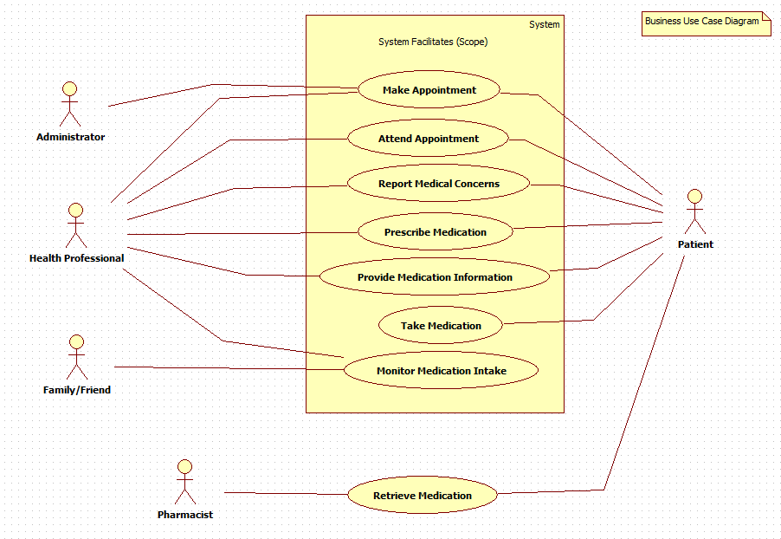

|  |  |  |
| --- | --- | --- |
| Use Case Name: Register Account | ID: 1 | Importance Level: High |
| Primary Actor: User | Use Case Type: Detailed, Essential | |
| Stakeholders and Interests:  User – wants to make an account to utilize NurseEllie | | | |
| Brief Description: This use case describes how users create and register their account | | | |
| Trigger: User requires or would like to utilize NurseEllie's services  Type: External | | | |
| Relationships:  Association: User  Include:  Extend: Change User Settings  Generalization: | | | |
| Normal Flow of Events:  1. The user downloads or access NurseEllie application  2. The user provides their first- and last- name, email, preferred password, and password verification  3. The user verifies the validity of their email through email verification  If the user is a patient, no further action required  If the user is a health professional, provide profession and ID.  If the user is a family member or friend, provide patient User ID to connect.  4. The user has an account with the appropriate user type (patient, health professional, family/friend) | | | |
| Sub flows:  Sign-In to Account | | | |
| Alternate/Exceptional Flows:  2a. The account for the provided email exists, user must sign-in or use different email.  3a. The user chose not to verify their email, the account creation process freezes. | | | |

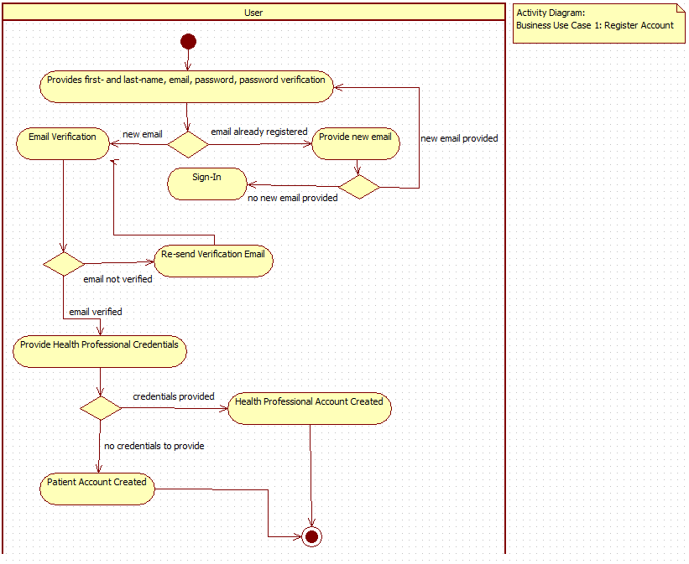

|  |  |  |
| --- | --- | --- |
| Use Case Name: Set Up Payment | ID: 2 | Importance Level: High |
| Primary Actor: Health Professional | Use Case Type: Detail, Essential | |
| Stakeholders and Interests: Health Professional – wants to monitor and connect with patient by utilizing health professional functionalities of NurseEllie application Payment Processing Company – wants to process payment made (provide their service) | | |
| Brief Description: The use case enables the health professional to pay for subscription to NurseEllie to access health professional functionalities of the application | | |
| Trigger: Money is owed for health professional functionalities of NurseEllie | | |
| Type: Temporal | | |
| Relationships: |  |  |
| Association: Health Professional | | |
| Include: | | |
| Extend: Change User Settings | | |
| Generalization: | | |
| Normal Flow of Events: 1. Health professional selects subscription model (i.e. monthly/yearly) 2. Health professional selects payment method 3. Health professional provides appropriate credentials to make payment 4. Payment processing company verifies payment 5. Health professional paid for subscription | | |
| Subflows: | | |
| Alternate/Exceptional Flows: 3a. Payment method is invalid, payment is rejected | | |

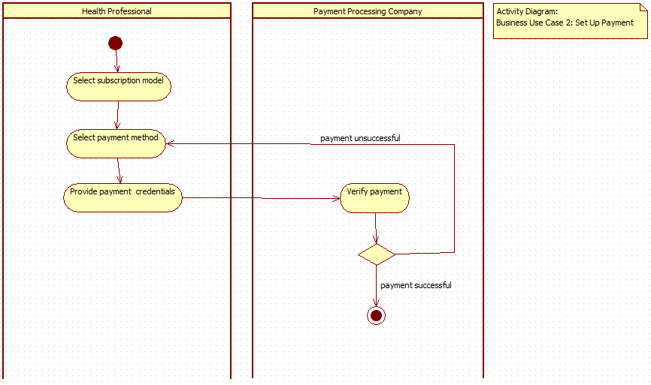

|  |  |  |
| --- | --- | --- |
| Use Case Name: Register User To Another | ID: 3 | Importance Level: High |
| Primary Actor: Health Professional | Use Case Type: Detail, Essential | |
| Stakeholders and Interests: Health Professional – wants to monitor and connect with patient  Family Member/Friend – wants to monitor patient Patient – wants to connect to health professional | | |
| Brief Description: The use case allows the patient and health professional or family member/friend to connect accounts to allow for direct communication and activity monitoring. | | |
| Trigger: Patient or Health Professional/Family Member/Friend would like to connect with other party | | |
| Type: External | | |
| Relationships: |  |  |
| Association: Health Professional, Patient | | |
| Include: | | |
| Extend: Change User Settings | | |
| Generalization: | | |
| Normal Flow of Events: 1. User selects type of connection  If the user is a patient, only connections to health professional or family member can be made  If the user is a health professional, only connections to patients can be made  If the user is a family member, only connections to health professional, patient can be made 2. User selects input method (i.e. type invitation code, scan QR code) 3. Another user provides invitation code and delivery method (i.e. type invitation code, scan QR code) 4. User inputs invitation code  5. Connection is made | | |
| Subflows: | | |
| Alternate/Exceptional Flows: 4a. Invitation ID is invalid or expired, connection is cancelled | | |

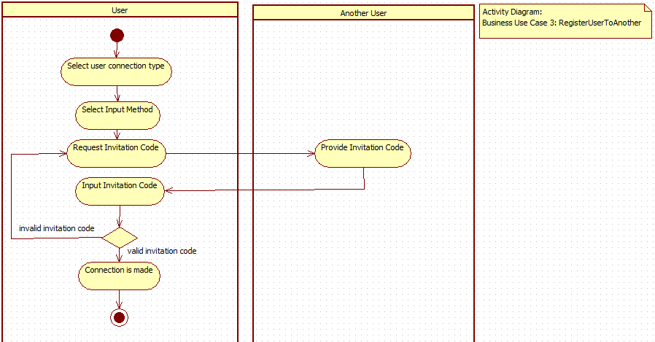

|  |  |  |
| --- | --- | --- |
| Use Case Name: ManageMedications | ID: 4 | Importance Level: High |
| Primary Actor: User | Use Case Type: Detail, Essential | |
| Stakeholders and Interests: User - wants to add, change, or remove medication in regime | | |
| Brief Description: This use case describes how medications are added, removed or changed. | | |
| Trigger: User has changes to medication regime | | |
| Type: External | | |
| Relationships: |  |  |
| Association: User | | |
| Include: | | |
| Extend: | | |
| Generalization: | | |
| Normal Flow of Events: 1. User requests list of current medications in regime 2. If details of medication in current regime needs to be changed,  the S-1: Modify Saved Medication subflow is performed 3. If medication not in current regime needs to be added,  the S-2: Add New Medication subflow is performed 4. If User is health professional and medication in current regime needs to be removed,  the S-3: Delete Saved Medication subflow is performed 5. Repeat steps 1-4 if User needs to manage more medications | | |
| Subflows: S-1: Modify Saved Medication  1. The User selects a saved medication that has dosage or frequency that needs to be changed  2. The User changes any medication settings including strength, dosage time, frequency S-2: Add New Medication  1. The User enters name of medication and settings including strength, dosage time, frequency S-3: Deleted Saved Medication  1. The User selects a saved medication to be deleted | | |
| Alternate/Exceptional Flows: | | |

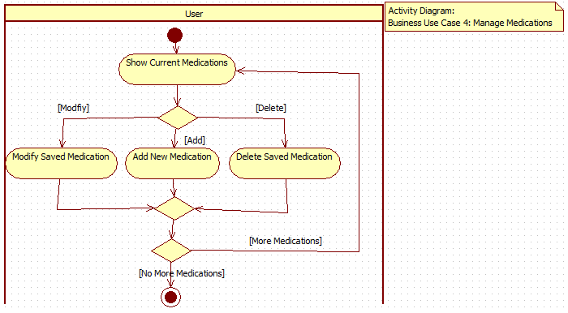

|  |  |  |
| --- | --- | --- |
| Use Case Name: ViewMedications | ID: 5 | Importance Level: High |
| Primary Actor: User | Use Case Type: Detail, Essential | |
| Stakeholders and Interests: User - User wants to have overview of current medications, or specific medication information | | |
| Brief Description:  This use case describes how details for current medications can be viewed | | |
| Trigger: | | |
| Type: External | | |
| Relationships: |  |  |
| Association: User, Health Professional, Patient | | |
| Include: | | |
| Extend: Submit Symptom Checklist. Request Symptom Checklist | | |
| Generalization: | | |
| Normal Flow of Events:  1. User views list of current medications  2. If user wants to view medication details  User views medication details  3. If Health Professional wants to request symptom checklist from patient  Health Professional requests symptom checklist  4. If Patient wants to submit symptom checklist  Patient submits symptom checklist | | |
| Subflows: | | |
| Alternate/Exceptional Flows: | | |

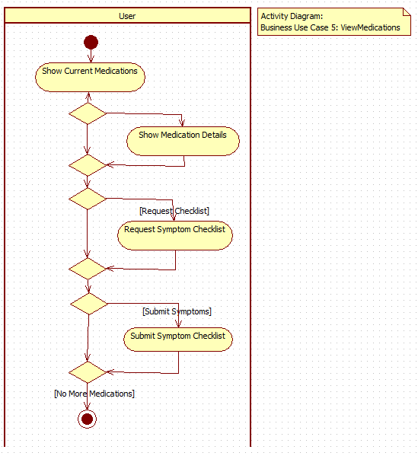

|  |  |  |
| --- | --- | --- |
| Use Case Name: ChangeMedicationNotifications | ID: 6 | Importance Level: Medium |
| Primary Actor: User | Use Case Type: Detail, Essential | |
| Stakeholders and Interests: User - User wants to change default notifications for all or custom notification for certain medications. | | |
| Brief Description:  This use case describes how users change medication notifications | | |
| Trigger: User has changes to medication regime | | |
| Type: External | | |
| Relationships: |  |  |
| Association: User | | |
| Include: | | |
| Extend: | | |
| Generalization: | | |
| Normal Flow of Events: 1. User views default notifications that applies to all medications and list of custom notifications 2. If User wants to change the notification for specific medication  User selects existing custom notification medication or adds new 3. If user wants to change refill reminder notifications settings  User changes reminder notifications 4. If user wants to change intake reminder  User changes intake reminder | | |
| Subflows: | | |
| Alternate/Exceptional Flows: | | |

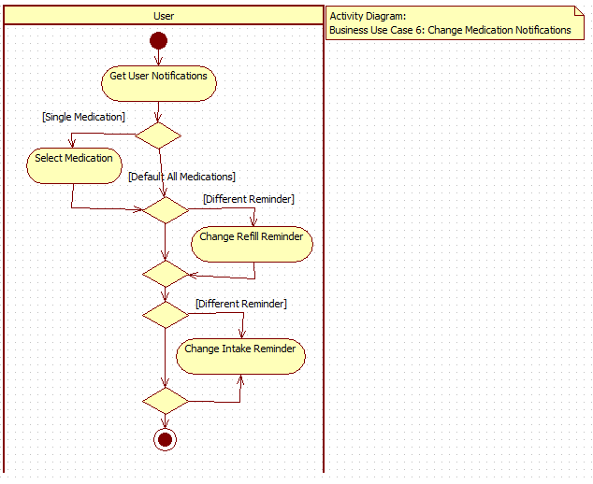

|  |  |  |
| --- | --- | --- |
| Use Case Name: ScheduleAppointment | ID:  7 | Importance Level: High |
| Primary Actor: User | Use Case Type: Detail, Essential | |
| Stakeholders and Interests:  User – wants to make an appointment | | |
| Brief Description: This use case describes how users select a suitable time to request an appointment and provide details on patient complaints for the health professional to confirm | | |
| Trigger: User requires or would like to schedule a virtual meeting with a health professional by NurseEllie  Type: External | | |
| Relationships:                 Association: User                 Include:                 Extend:                 Generalization: | | |
| Normal Flow of Events:  1. The user views and selects their recipient              If user is a patient, patient checks a list of their health professionals and selects a health professional              If user is a health professional, health professional checks a list of health professionals and selects a patient  2. The user select their suitable date and time               If user is a patient, patient checks health professional’s schedule for available time               If user is a health professional, health professional sends their preferred date/time.  3. Recipient user checks appointment request              If user accepts appointment request, confirmation will be sent              If user does not accept, alternative date/time can be provided.  4. The user receives a confirmation about their appointment. | | |
| Sub flows:  Sign-In to Account  System insert a new appointment for a specific patient | | |
| Alternate/Exceptional Flows: | | |

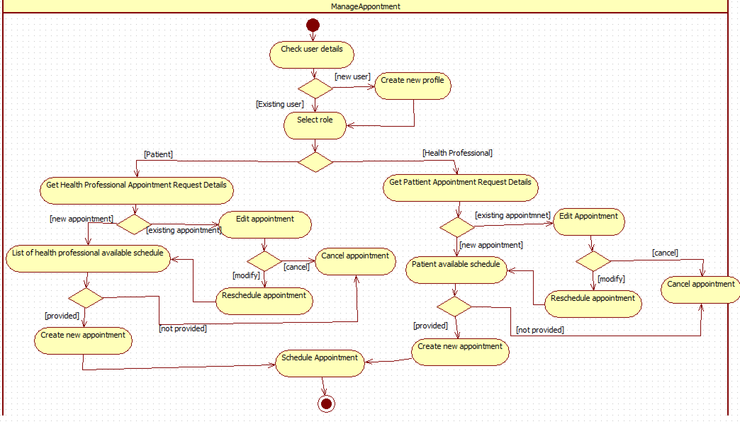

|  |  |  |
| --- | --- | --- |
| Use Case Name: CancelAppointment | ID:  8 | Importance Level: High |
| Primary Actor: User | Use Case Type: Detail, Essential | |
| Stakeholders and Interests:  User – wants to cancel an appointment | | |
| Brief Description: This use case describes how users delete an existing scheduled appointment and alert the other party. | | |
| Trigger: User would like to re-schedule or cancel a virtual meeting by NurseEllie   Type: External | | |
| Relationships:                 Association: User                 Include: ScheduleAppointment                 Extend:                 Generalization: | | |
| Normal Flow of Events:  1. The user select their appointment  2. The system check if there is a matching appointment  3. The user receives a select to cancel.               If user wants to reschedule, schedule appointment               If user wants to cancel, appointment is removed  4.. The user got a confirmation about their new appointment status. | | |
| Sub flows:  Sign-In to Account  System saved new status of the appointment | | |
| Alternate/Exceptional Flows: | | |

|  |  |  |
| --- | --- | --- |
| Use Case Name: RequestSymptomChecklist | ID: 9 | Importance Level: High |
| Primary Actor: Health Professional | Use Case Type: Detail, Essential | |
| Stakeholders and Interests: Patient - wants to provide feedback to the health professional.  Health Professional - wants to check in with the patient symptoms. | | |
| Brief Description:  This use case enables a health professional to request their patient to complete a SymptomChecklist survey. | | |
| Trigger: Health Professional sends a request to the patient to fill in the symptom checklist through the app. | | |
| Type: External | | |
| Relationships: |  |  |
| Association: Health Professional | | |
| Include: | | |
| Extend: | | |
| Generalization: | | |
| Normal Flow of Events:  1. The Health Professional views patient's records and medicine intake history.  If patient has not taken any medicine, no need for symptom checklist.   If patient has taken one or more prescription, a checklist can be issued.  2. Health Professional sends a symptom checklist for the patient to fill out. | | |
| Subflows: | | |
| Alternate/Exceptional Flows: | | |

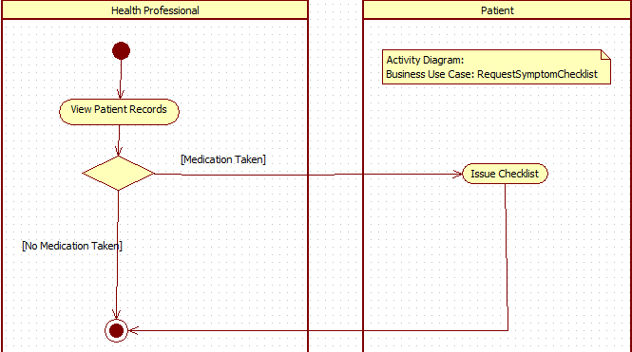

|  |  |  |
| --- | --- | --- |
| Use Case Name: SubmitSymptomChecklist | ID: 10 | Importance Level: High |
| Primary Actor: Patient | Use Case Type: Detail, Essential | |
| Stakeholders and Interests: Patient - wants to submit a checklist of symptoms from medicine. Health Professional - wants to see the checklist of symptoms from patient. | | |
| Brief Description: This use case enables a patient to send the SymptomChecklist record to a health professional. | | |
| Trigger: The Health Professional has prompted the patient to submit a checklist.  Type: External | | |
| **OR** | | |
| Trigger: The patient has experienced symptoms from the medicine and wants to submit a checklist. | | |
| Type: External | | |
| Relationships: |  |  |
| Association: Patient | | |
| Include: | | |
| Extend: RequestSymptomChecklist | | |
| Generalization: | | |
| Normal Flow of Events: 1a. The patient will receive an alert from the health professional to fill a symptom checklist.  2a. The patient views the alert and is brought to the page of the symptom checklist. 3a. The patient fills in the checklist   If the patient decides to save their checklist progress, they can save draft.  If the patient decides the checklist is filled properly, they can submit.  4a. Submitted symptom checklist will be sent to the corresponding health professional.   1b. The patient is experiencing symptoms from the taken prescription. 2b. The patient views the page of the prescription that they have symptoms for. 3b. The patient selects the option to submit a symptom checklist to their health professional. 4b. The patient fills in the checklist   If the patient decides to save their checklist progress, they can save draft.  If the patient decides the checklist is filled properly, they can submit.  5b. Submitted symptom checklist will be sent to the corresponding health professional. | | |
| Subflows: | | |
| Alternate/Exceptional Flows: 3a, E1: The patient refuses to fill out the checklist. | | |

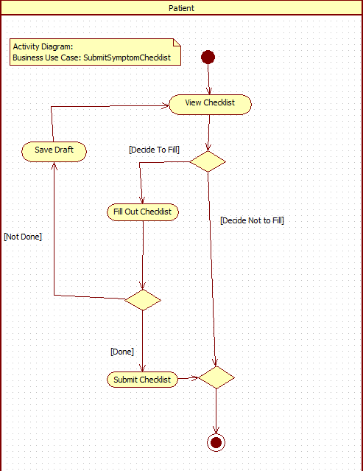

|  |  |  |
| --- | --- | --- |
| Use Case Name: ViewFeedback | ID: 11 | Importance Level: High |
| Primary Actor: Health Professional | Use Case Type: Detail, Essential | |
| Stakeholders and Interests: Health Professional - wants to check up on their patient. Patient - has their health information submitted for health professional to view. | | |
| Brief Description: This use case enables a health professional to view information submitted by their patient including: Symptom Checklist, patient medication adherence, blood-glucose monitoring result. | | |
| Trigger: Health Professional checks up on the patient to view their medical condition. | | |
| Type: External | | |
| Relationships: |  |  |
| Association: Health Professional | | |
| Include: | | |
| Extend: | | |
| Generalization: | | |
| Normal Flow of Events:  1. Health Professional goes to patient's record to check up on them. 2. If patient has filled out symptom checklists  Health Professional can view checklists for each medication taken. 3. If patient has existing medication, they have to take  Health Professional can view their medication usage track record.  4. If patient has their blood-glucose monitored  Health Professional can view their blood-glucose results. | | |
| Subflows: | | |
| Alternate/Exceptional Flows: | | |

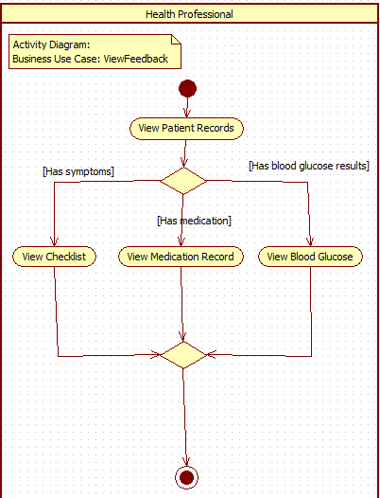

|  |  |  |
| --- | --- | --- |
| Use Case Name: ShareMedicalLog | ID: 12 | Importance Level: High |
| Primary Actor: Patient | Use Case Type: Detail, Essential | |
| Stakeholders and Interests: Patient - wants to share their medication information to family or friends.  Family/Friends - wants to view patient's medical information. | | |
| Brief Description: This use case enables the patient to share their current medications and history with friends and family. | | |
| Trigger: Patient decides to share their medical information. | | |
| Type: External | | |
| Relationships: |  |  |
| Association: Patient | | |
| Include: | | |
| Extend: | | |
| Generalization: | | |
| Normal Flow of Events: 1. Patient goes to their profile and gets the option to export/share their information. 2. Patient can choose which medical information they can share (medication, blood-glucose).   If patient chooses medication, only medication will be exported.  If patient chooses blood-glucose results, only that will be exported.  If patient chooses all, everything will be exported. 3. Once patient decides what information to export, they export it and a code will be generated. 4. A link to the medical log will also be generated and can only be accessed with the code. | | |
| Subflows: | | |
| Alternate/Exceptional Flows: | | |

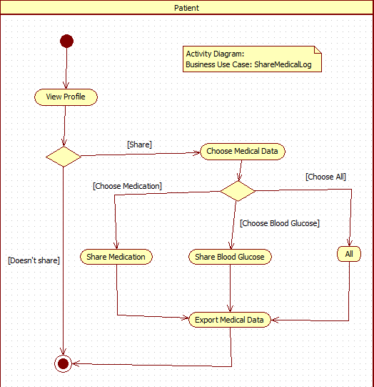

|  |  |  |
| --- | --- | --- |
| Use Case Name: ReportExternalClinicVisitationInformation | ID:  14 | Importance Level: High |
| Primary Actor: User | Use Case Type: Detailed, Essential | |
| Stakeholders and Interests:  User – wants to inform a heath professional any external information | | |
| Brief Description: This use case describes how users report external information to the health professional about their side effects of the medicine, any allergy, or unusual manifestations | | |
| Trigger: User requires or would like to provide more information after visit clinic  Type: Internal | | |
| Relationships:                 Association: User                 Include:                 Extend:                 Generalization: | | |
| Normal Flow of Events:  1. The user select their view to report external.  2. The user provide if they are allergic to the medication, or if they having unusual manifestations.  3. The user got a confirmation about report is received. | | |
| Sub flows:  Sign-In to Account  System insert a new report for a specific patient. | | |
| Alternate/Exceptional Flows: | | |

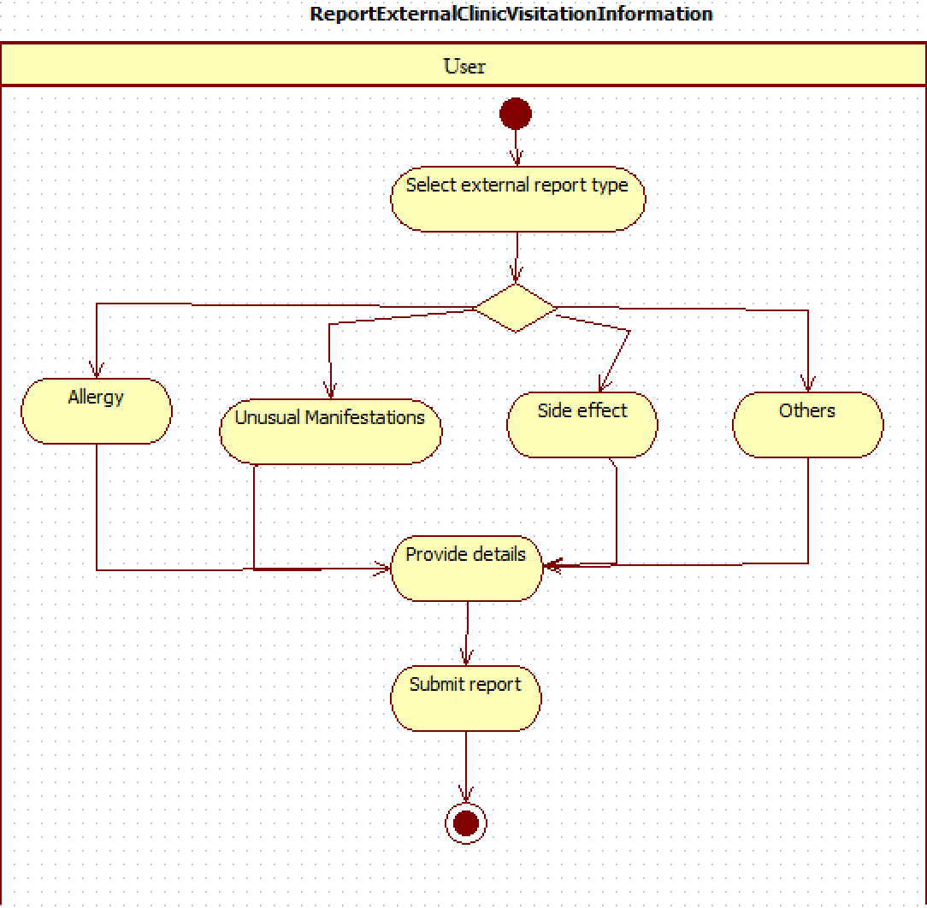

## **Conceptual Model**

## 

**Level 0 Data Flow Diagram**

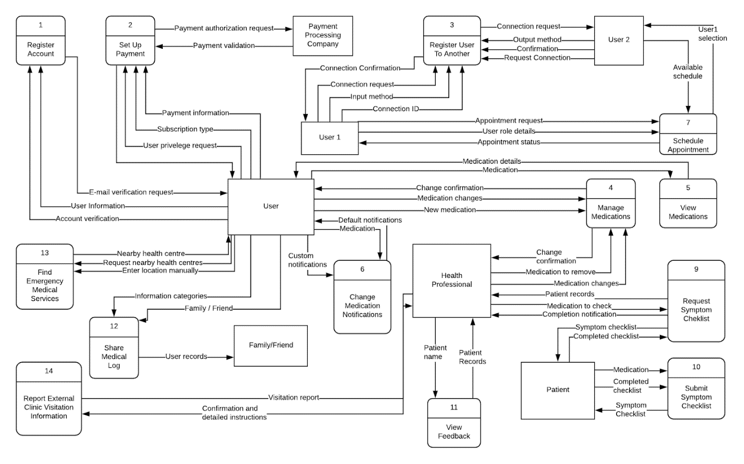

**Doman Class Diagram**

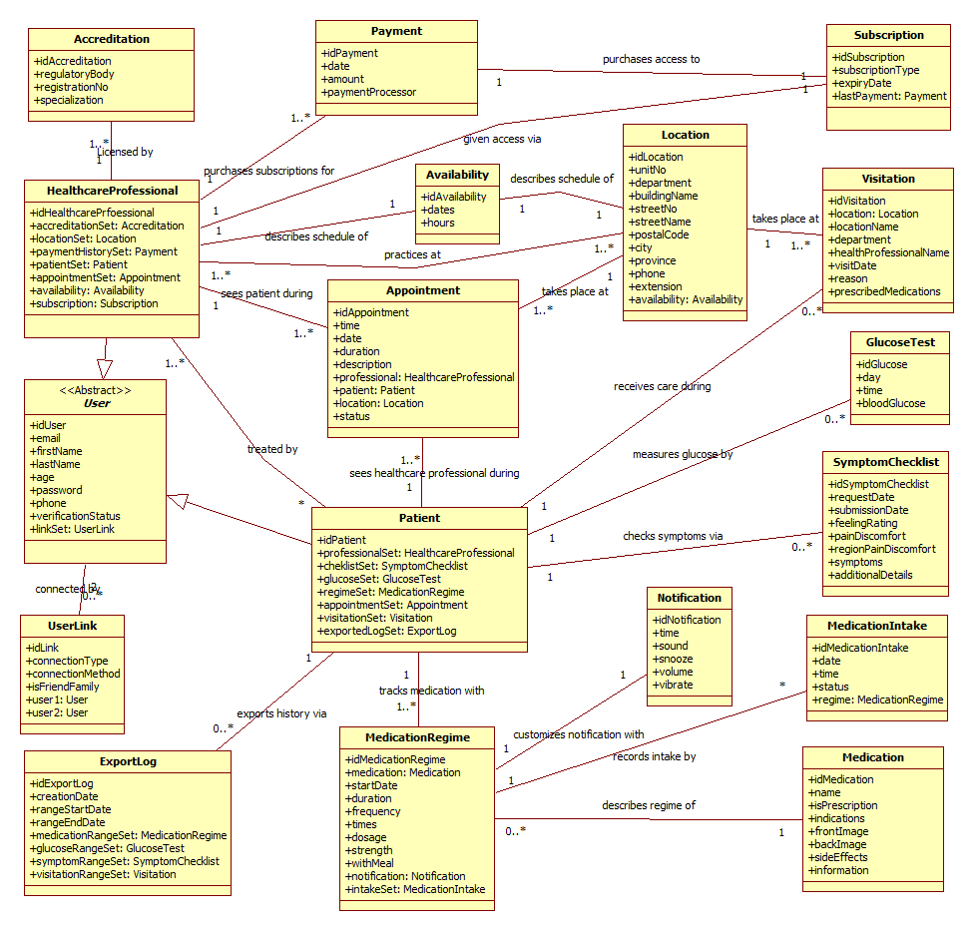

**3.3 Interface Mock-ups**

The following interface mock-ups demonstrate the app loading screen, login and registration pages.

 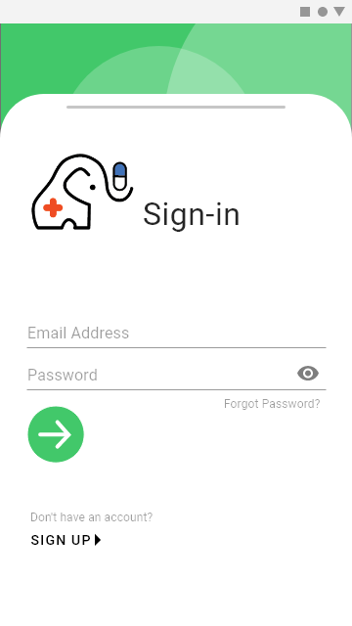 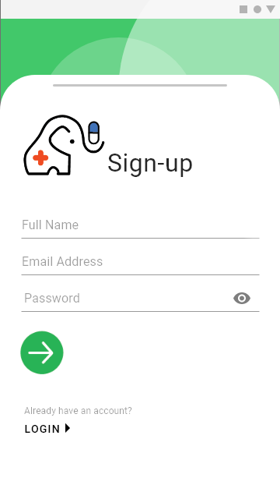

The following interface mock-ups demonstrate the application’s home page what the user would first see after logging in, and the menu screen after selecting the hamburger icon on the top right.

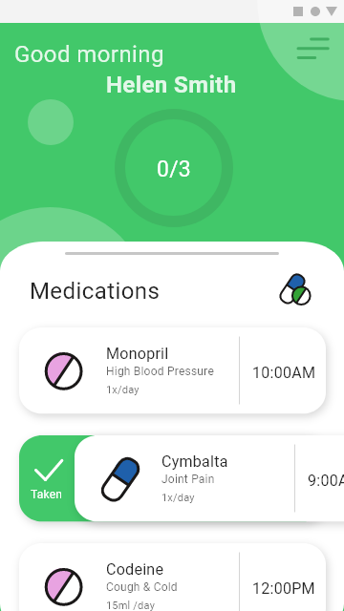 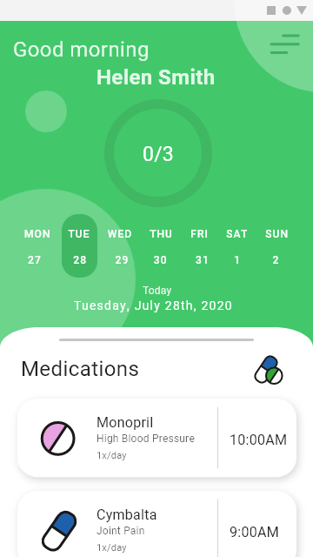 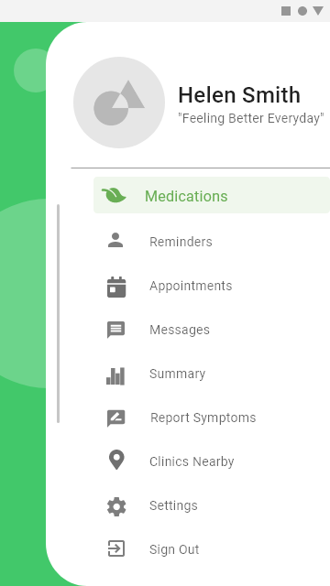

The following interface mock-up screens demonstrate how users would connect to each other.

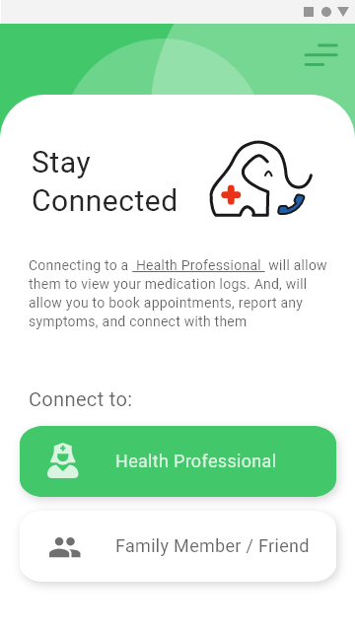 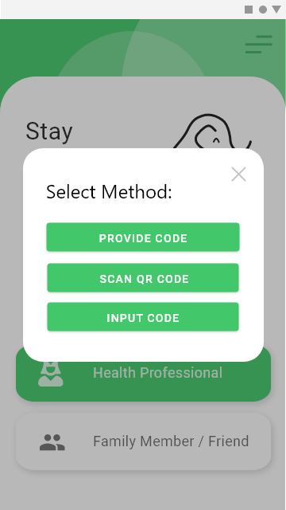 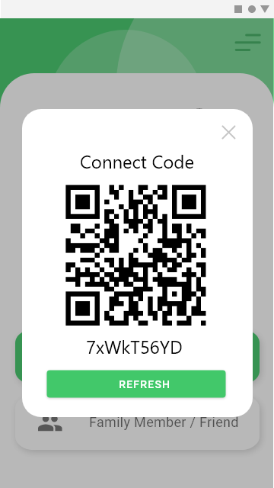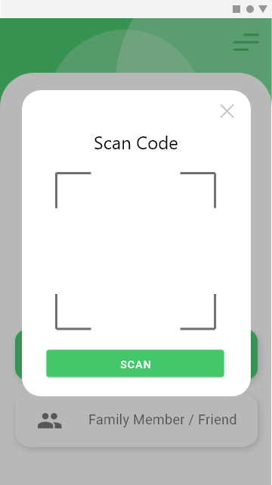 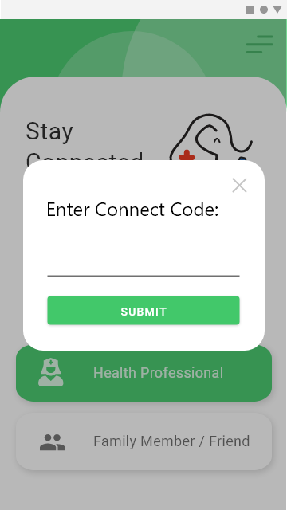

The following interface mock-ups illustrate how a user would manage their medications: viewing medication details, editing their medication intake schedule or adding over the counter medication.

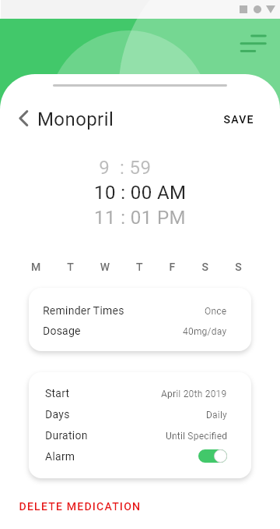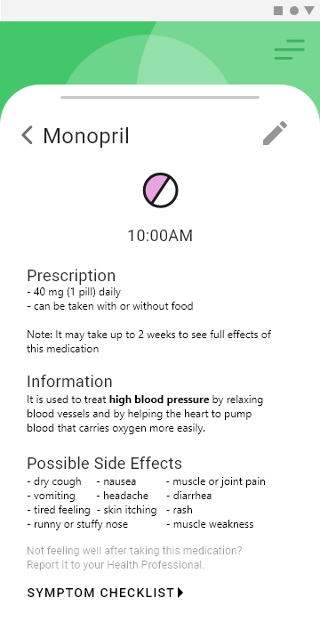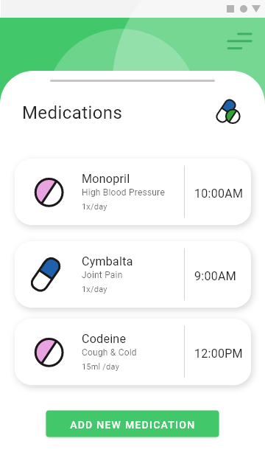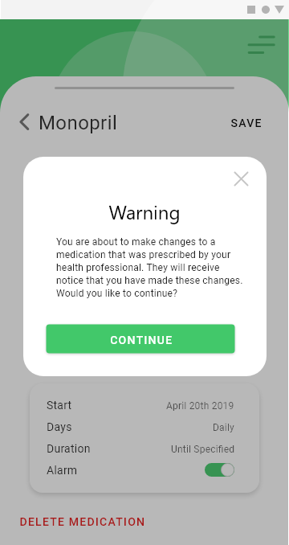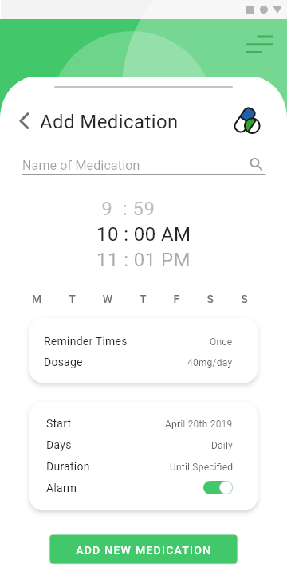

The interface mock-ups illustrate how a user would receive a notification to complete a symptom checklist and complete the symptom checklist.

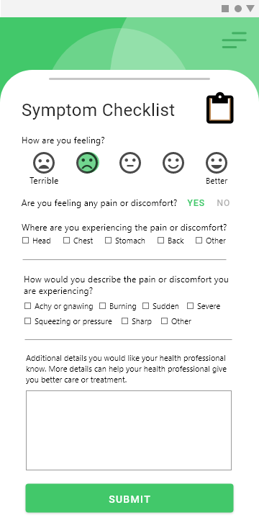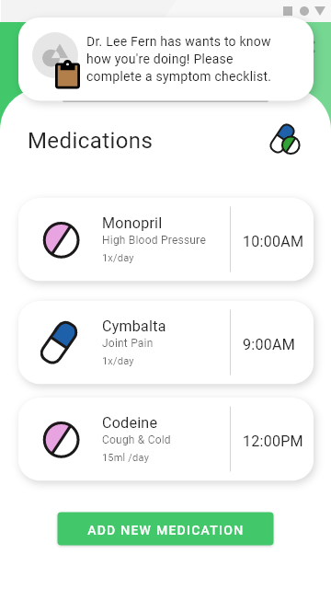The follow interface mock-ups illustrate how a user would view a reminder for medication intake, in which acknowledge would indicate proper consumption to the health professional

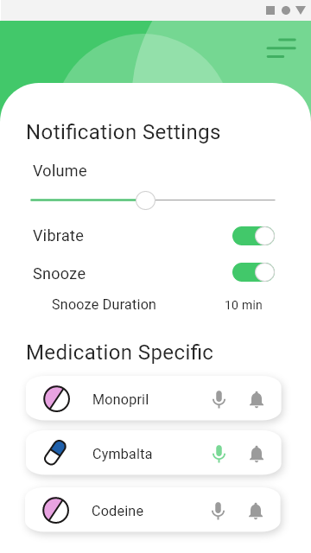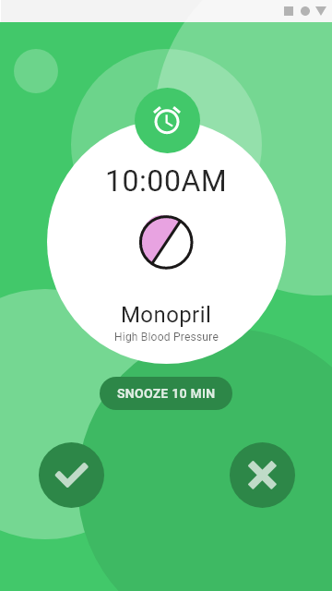

The following interfaces illustrate how a user would manage their appointments with their health professionals.

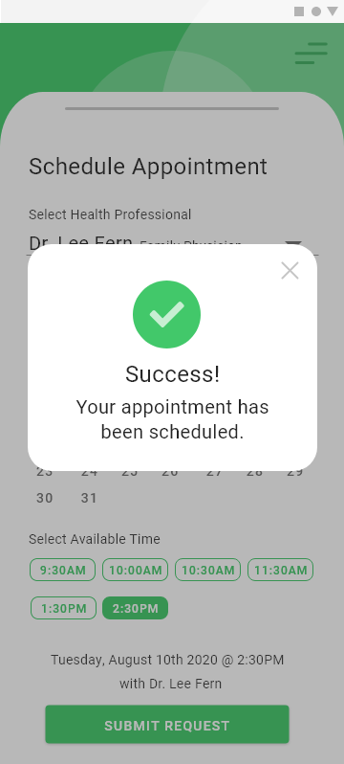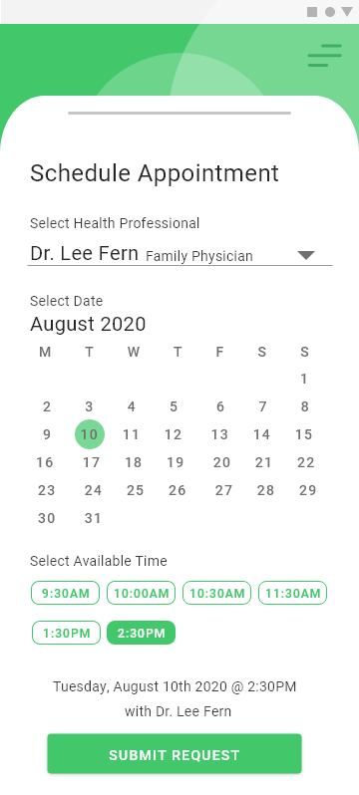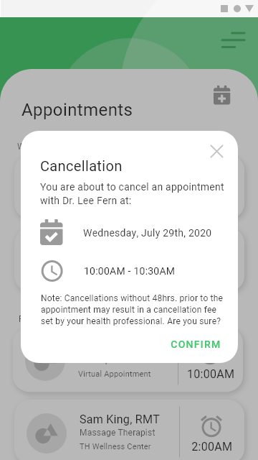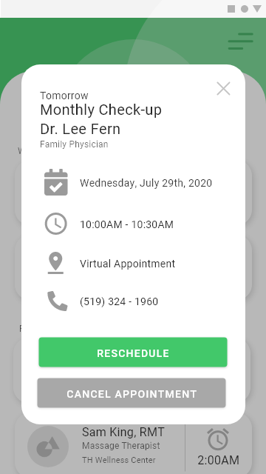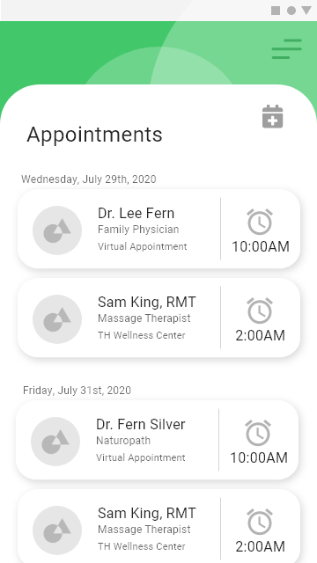The following interfaces demonstrate how a user would view their medication intake record and share with their health professional or family and friends.

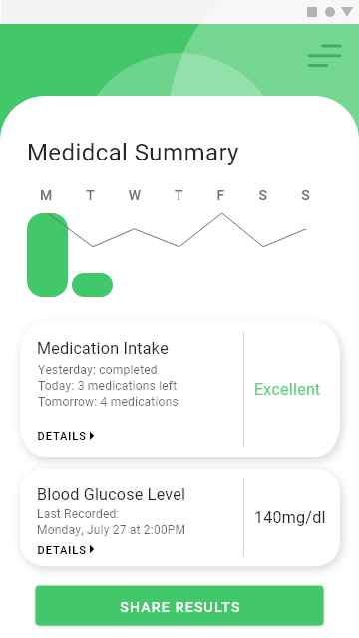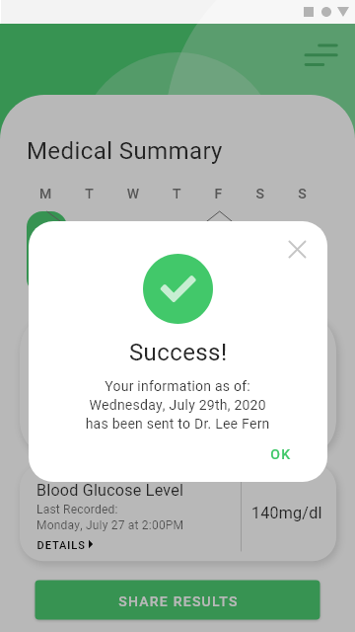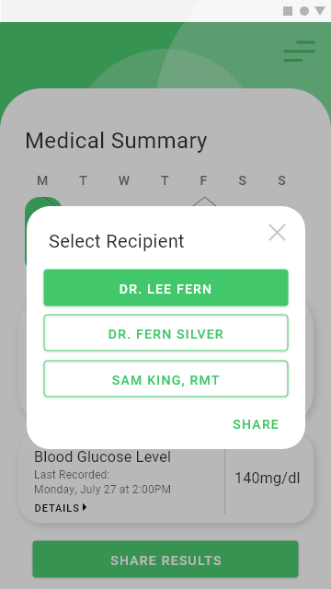The interface mockup screens below illustrate how a user would search for nearby clinics or hospital in case their health professional is unavailable. And, a form they can complete to report any external clinical visits

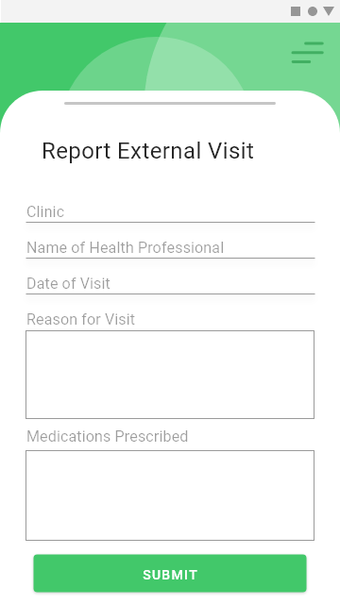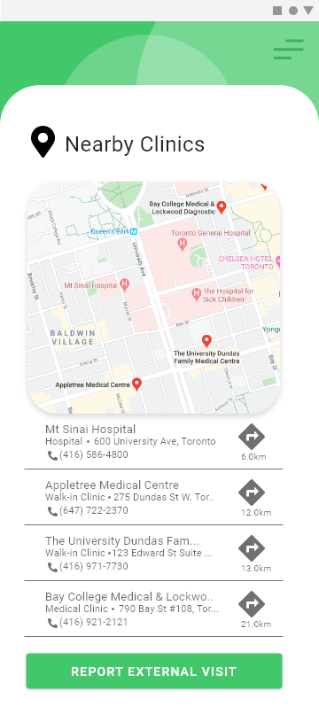**HEALTH PROFESSIONAL’S VIEW**

|  |  |  |
| --- | --- | --- |
| 1. Entry Screen | 1. Sign-in | 1. Registration |
|  |  |  |
| 1. Home Page | 1. Menu | 1. Connect with others |
|  |  |  |
| 1. Connection Method | 1. Output Connect Code | 1. Scan QR Code |
|  |  |  |
| 1. Input Code | 1. View Patients | 1. View Patient Details |
|  |  |  |
| 1. Add Patient Medication | 1. Add Patient Medication Success | 1. View Patient Symptom Checklist |
|  |  |  |
| 1. View Appointments | 1. Appointment Details | 1. Schedule Appointment |
|  |  |  |
| 1. Schedule Appointment Success | 1. Cancel Appointment | 1. Appointment Alarm |
|  |  |  |
| 1. Notification Settings | 1. Subscriptions | 1. Subscription Payment Login |
|  |  |  |
| 1. Subscription Payment Confirmation | 1. Subscription Payment Success | |
|  |  | |

**HEALTH PROFESSIONAL’S DASHBOARD**

1. Dashboard Homepage

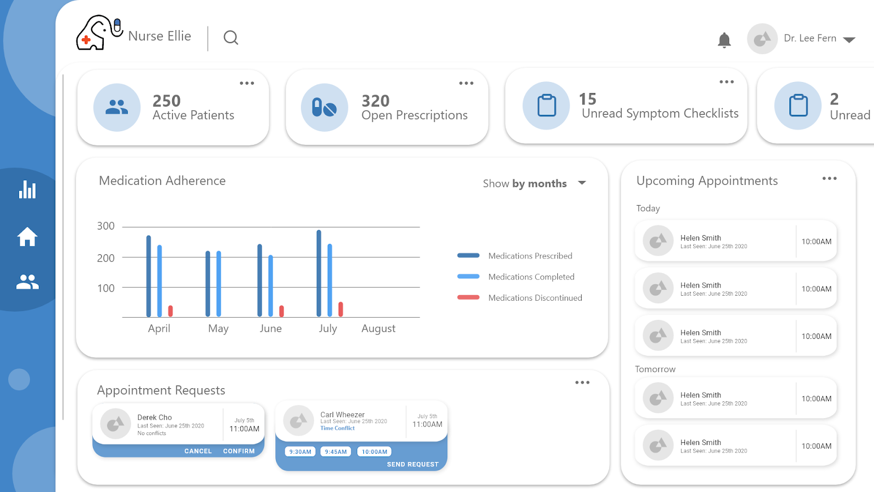

1. Patient Dashboard

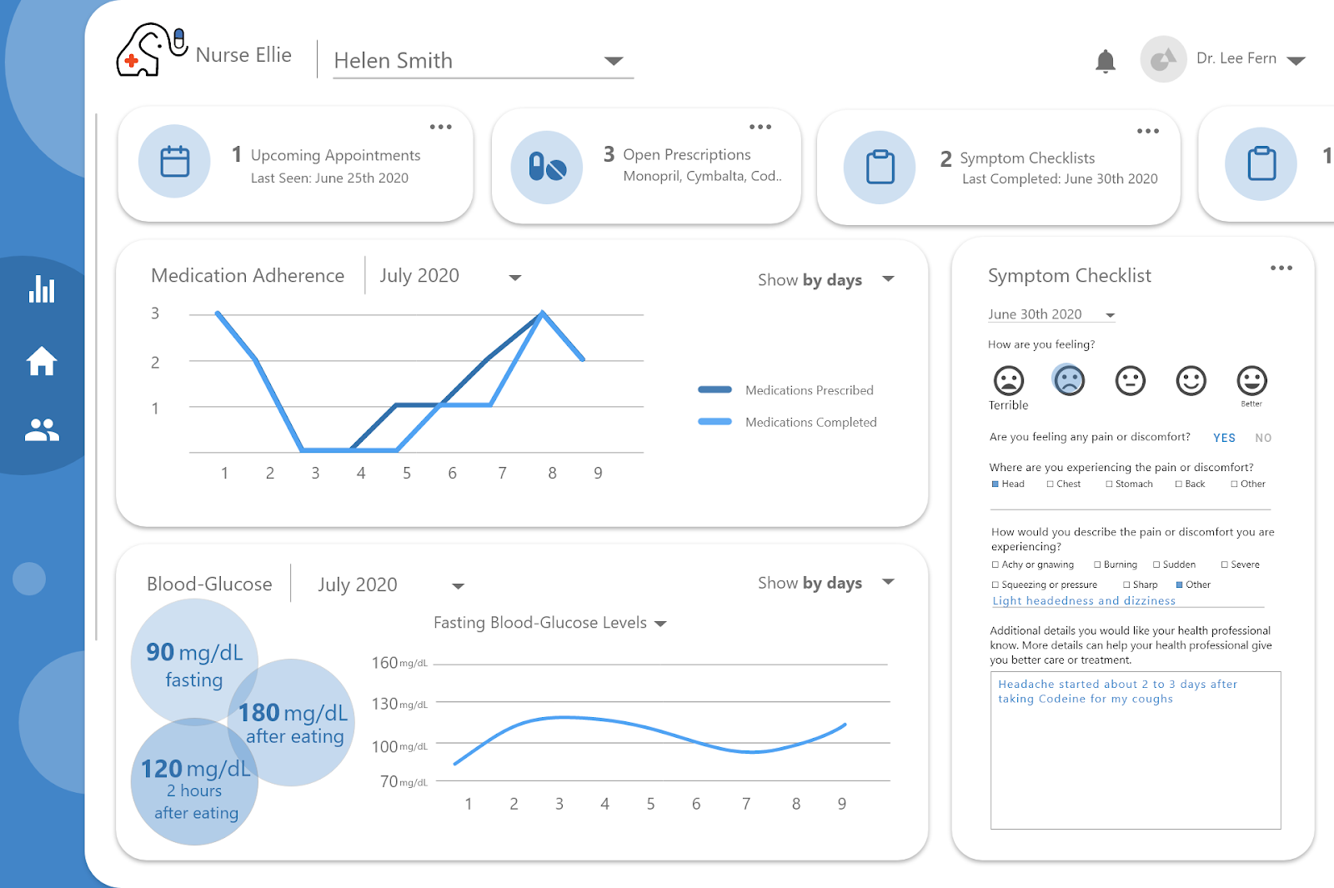

1. Appointments Dashboard

# 4. Database

## 

## 4.1. Scripts to create, populate, delete tables

CREATE TABLE `Accreditation` (

`idAccreditation` int NOT NULL,

`regulatoryBody` varchar(45) DEFAULT NULL,

`registrationNo` varchar(45) DEFAULT NULL,

`specialization` varchar(45) DEFAULT NULL,

PRIMARY KEY (`idAccreditation`)

) ENGINE=InnoDB DEFAULT CHARSET=utf8mb4 COLLATE=utf8mb4_0900_ai_ci;

s

CREATE TABLE `Appointment` (

`idAppointment` int NOT NULL,

`time` datetime DEFAULT NULL,

`date` datetime DEFAULT NULL,

`duration` int DEFAULT NULL,

`professional` int DEFAULT NULL,

`patient` varchar(45) DEFAULT NULL,

`location` int DEFAULT NULL,

`status` varchar(45) DEFAULT NULL,

PRIMARY KEY (`idAppointment`),

KEY `loca_id_fk_idx` (`location`),

KEY `profess_fk_idx` (`professional`),

CONSTRAINT `loca_id_fk` FOREIGN KEY (`location`) REFERENCES `Location` (`idLocation`),

CONSTRAINT `profess_fk` FOREIGN KEY (`professional`) REFERENCES `HealthcareProfessional` (`idHealthcareProfessional`)

) ENGINE=InnoDB DEFAULT CHARSET=utf8mb4 COLLATE=utf8mb4_0900_ai_ci;

CREATE TABLE `Availability` (

`idAvailability` int NOT NULL,

`dates` datetime DEFAULT NULL,

`hours` int DEFAULT NULL,

PRIMARY KEY (`idAvailability`)

) ENGINE=InnoDB DEFAULT CHARSET=utf8mb4 COLLATE=utf8mb4_0900_ai_ci;

CREATE TABLE `ExportLog` (

`idExportLog` int NOT NULL,

`creationDate` datetime DEFAULT NULL,

`rangeStartDate`datetime DEFAULT NULL,

`rangeEndDate` datetime DEFAULT NULL,

`medicationRangeSet` int DEFAULT NULL,

`glucoseRangeSet` int DEFAULT NULL,

`symptomRangeSet` int DEFAULT NULL,

`visitationRangeSet` int DEFAULT NULL,

PRIMARY KEY (`idExportLog`)

) ENGINE=InnoDB DEFAULT CHARSET=utf8mb4 COLLATE=utf8mb4_0900_ai_ci;

CREATE TABLE `GlucoseTest` (

`idGlucoseTest` int NOT NULL,

`day` datetime DEFAULT NULL,

`time` datetime DEFAULT NULL,

`bloodGlucose` varchar(45) DEFAULT NULL,

PRIMARY KEY (`idGlucoseTest`)

) ENGINE=InnoDB DEFAULT CHARSET=utf8mb4 COLLATE=utf8mb4_0900_ai_ci;

CREATE TABLE `HealthcareProfessional` (

`idHealthcareProfessional` int NOT NULL,

`accreditationSet:` int DEFAULT NULL,

`locationSet` int DEFAULT NULL,

`paymentHistorySet` int DEFAULT NULL,

`patientSet` int DEFAULT NULL,

`appointmentSet` int DEFAULT NULL,

`availability` int DEFAULT NULL,

`subscription` int DEFAULT NULL,

`userSet` int DEFAULT NULL,

PRIMARY KEY (`idHealthcareProfessional`),

KEY `accredic_fk_idx` (`accreditationSet:`),

KEY `locaset_fk_idx` (`locationSet`),

KEY `paymentHis_fk_idx` (`paymentHistorySet`),

KEY `appointmentSet_fk_idx` (`appointmentSet`),

KEY `avail_fk_idx` (`availability`),

KEY `subscript_fk_idx` (`subscription`),

KEY `userIdSet_fk_idx` (`userSet`),

CONSTRAINT `accredic_fk` FOREIGN KEY (`accreditationSet:`) REFERENCES `Accreditation` (`idAccreditation`),

CONSTRAINT `appointmentSet_fk` FOREIGN KEY (`appointmentSet`) REFERENCES `Appointment` (`idAppointment`),

CONSTRAINT `avail_fk` FOREIGN KEY (`availability`) REFERENCES `Availability` (`idAvailability`),

CONSTRAINT `locaset_fk` FOREIGN KEY (`locationSet`) REFERENCES `Location` (`idLocation`),

CONSTRAINT `paymentHis_fk` FOREIGN KEY (`paymentHistorySet`) REFERENCES `Payment` (`idPayment`),

CONSTRAINT `subscript_fk` FOREIGN KEY (`subscription`) REFERENCES `Subscription` (`idSubscription`),

CONSTRAINT `userIdSet_fk` FOREIGN KEY (`userSet`) REFERENCES `User` (`idUser`)

) ENGINE=InnoDB DEFAULT CHARSET=utf8mb4 COLLATE=utf8mb4_0900_ai_ci;

CREATE TABLE `Location` (

`idLocation` int NOT NULL,

`unitNo` int DEFAULT NULL,

`department` varchar(45) DEFAULT NULL,

`buildingName` varchar(45) DEFAULT NULL,

`streetNo` int DEFAULT NULL,

`streetName` varchar(45) DEFAULT NULL,

`postalCode` varchar(45) DEFAULT NULL,

`city` varchar(45) DEFAULT NULL,

`province` varchar(45) DEFAULT NULL,

`phone` varchar(45) DEFAULT NULL,

`extension` varchar(45) DEFAULT NULL,

`availability` int DEFAULT NULL,

PRIMARY KEY (`idLocation`)

KEY `avail_fk_idx` (`availability`),

CONSTRAINT `avail_fk` FOREIGN KEY (`availability`) REFERENCES `Availability` (`idAvailability`)

) ENGINE=InnoDB DEFAULT CHARSET=utf8mb4 COLLATE=utf8mb4_0900_ai_ci;

CREATE TABLE `Medication` (

`idMedication` int NOT NULL,

`name` varchar(45) DEFAULT NULL,

`isPrescription` tinyint DEFAULT NULL,

`indications` varchar(45) DEFAULT NULL,

`frontImage` varbinary(128) DEFAULT NULL,

`backImage` varbinary(128) DEFAULT NULL,

`sideEffects` varchar(45) DEFAULT NULL,

`information` varchar(45) DEFAULT NULL,

PRIMARY KEY (`idMedication`),

UNIQUE KEY `frontImage_UNIQUE` (`frontImage`)

) ENGINE=InnoDB DEFAULT CHARSET=utf8mb4 COLLATE=utf8mb4_0900_ai_ci;

CREATE TABLE `MedicationIntake` (

`idMedicationIntake` int NOT NULL,

`date` datetime DEFAULT NULL,

`time` time DEFAULT NULL,

`status` varchar(45) DEFAULT NULL,

`regime` int DEFAULT NOT NULL,

PRIMARY KEY (`idMedicationIntake`),

KEY `regime_fk_idx` (`regime`),

CONSTRAINT `regime_fk` FOREIGN KEY (`regime`) REFERENCES `MedicationRegime` (`idMedicationRegime`),

) ENGINE=InnoDB DEFAULT CHARSET=utf8mb4 COLLATE=utf8mb4_0900_ai_ci;

CREATE TABLE `MedicationRegime` (

`idMedicationRegime` int NOT NULL,

`medication` int DEFAULT NULL,

`startDate` datetime DEFAULT NULL,

`duration` int DEFAULT NULL,

`frequency` int DEFAULT NULL,

`times` time DEFAULT NULL,

`dosage` varchar(45) DEFAULT NULL,

`strength` varchar(45) DEFAULT NULL,

`withMeal` boolean DEFAULT NULL,

`notification` int DEFAULT NULL,

`intakeSet` int DEFAULT NULL,

PRIMARY KEY (`idMedicationRegime`),

KEY `noti_fk_idx` (`notification`),

KEY `mediIntake_fk_idx` (`intakeSet`),

KEY `medication_fk_idx` (`medication`),

CONSTRAINT `medication_fk` FOREIGN KEY (`medication`) REFERENCES `Medication` (`idMedication`),

CONSTRAINT `mediIntake_fk` FOREIGN KEY (`intakeSet`) REFERENCES `MedicationIntake` (`idMedicationIntake`),

CONSTRAINT `noti_fk` FOREIGN KEY (`notification`) REFERENCES `Notification` (`idNotification`)

) ENGINE=InnoDB DEFAULT CHARSET=utf8mb4 COLLATE=utf8mb4_0900_ai_ci;

CREATE TABLE `Notification` (

`idNotification` int NOT NULL,

`time` int DEFAULT NULL,

`sound` varchar(45) DEFAULT NULL,

`snooze` varchar(45) DEFAULT NULL,

`volume` varchar(45) DEFAULT NULL,

`vibrate` boolean DEFAULT NULL,

PRIMARY KEY (`idNotification`)

) ENGINE=InnoDB DEFAULT CHARSET=utf8mb4 COLLATE=utf8mb4_0900_ai_ci;

CREATE TABLE `Patient` (

`idPatient` int NOT NULL,

`professionalSet` int DEFAULT NULL,

`cheklistSet` int DEFAULT NULL,

`glucoseSet` int DEFAULT NULL,

`regimeSet` int DEFAULT NULL,

`appointmentSet` int DEFAULT NULL,

`visitationSet` int DEFAULT NULL,

`exportedLogSet` int DEFAULT NULL,

`userSet` int DEFAULT NULL,

PRIMARY KEY (`idPatient`),

KEY `profSet_fk_idx` (`professionalSet`),

KEY `checklistSet_fk_idx` (`cheklistSet`),

KEY `glucose_fk_idx` (`glucoseSet`),

KEY `appointSet_fk_idx` (`appointmentSet`),

KEY `visitSet_fk_idx` (`visitationSet`),

KEY `exportLog_fk_idx` (`exportedLogSet`),

KEY `user_fk_idx` (`userSet`),

KEY `regime_fk_idx` (`regimeSet`),

CONSTRAINT `appointSet_fk` FOREIGN KEY (`appointmentSet`) REFERENCES `Appointment` (`idAppointment`),

CONSTRAINT `checklistSet_fk` FOREIGN KEY (`cheklistSet`) REFERENCES `SymptomChecklist` (`idSymptomChecklist`),

CONSTRAINT `exportLog_fk` FOREIGN KEY (`exportedLogSet`) REFERENCES `ExportLog` (`idExportLog`),

CONSTRAINT `glucose_fk` FOREIGN KEY (`glucoseSet`) REFERENCES `GlucoseTest` (`idGlucoseTest`),

CONSTRAINT `profSet_fk` FOREIGN KEY (`professionalSet`) REFERENCES `HealthcareProfessional` (`idHealthcareProfessional`),

CONSTRAINT `regime_fk` FOREIGN KEY (`regimeSet`) REFERENCES `MedicationRegime` (`idMedicationRegime`),

CONSTRAINT `user_fk` FOREIGN KEY (`userSet`) REFERENCES `User` (`idUser`),

CONSTRAINT `visitSet_fk` FOREIGN KEY (`visitationSet`) REFERENCES `Visitation` (`idVisitation`)

) ENGINE=InnoDB DEFAULT CHARSET=utf8mb4 COLLATE=utf8mb4_0900_ai_ci;

CREATE TABLE `Payment` (

`idPayment` int NOT NULL,

`date` datetime DEFAULT NULL,

`amount` int DEFAULT NULL,

`paymentProcessor` varchar(45) DEFAULT NULL,

PRIMARY KEY (`idPayment`),

) ENGINE=InnoDB DEFAULT CHARSET=utf8mb4 COLLATE=utf8mb4_0900_ai_ci;

CREATE TABLE `Subscription` (

`idSubscription` int NOT NULL,

`durationRemaining` varchar(45) DEFAULT NULL,

PRIMARY KEY (`idSubscription`)

) ENGINE=InnoDB DEFAULT CHARSET=utf8mb4 COLLATE=utf8mb4_0900_ai_ci;

CREATE TABLE `SymptomChecklist` (

`idSymptomChecklist` int NOT NULL,

`submissionDate`datetime DEFAULT NULL,

`requestDate` datetime (45) DEFAULT NULL,

`feelingRating` varchar(45) DEFAULT NULL,

`painDiscomfort` boolean DEFAULT NULL,

`regionPainDiscomfort` varchar(255) DEFAULT NULL,

`symptoms` varchar(255) DEFAULT NULL,

`additionalDetails` varchar(255) DEFAULT NULL,

PRIMARY KEY (`idSymptomChecklist`)

) ENGINE=InnoDB DEFAULT CHARSET=utf8mb4 COLLATE=utf8mb4_0900_ai_ci;

CREATE TABLE `User` (

`idUser` int NOT NULL,

`email` varchar(45) DEFAULT NULL,

`fName` varchar(45) DEFAULT NULL,

`lName` varchar(45) DEFAULT NULL,

`age` int DEFAULT NULL,

`password` varchar(45) DEFAULT NULL,

`phone` int DEFAULT NULL,

`verificationStatus` varchar(45) DEFAULT NULL,

`linkSet` int DEFAULT NULL,

PRIMARY KEY (`idUser`),

UNIQUE KEY `email_UNIQUE` (`email`),

UNIQUE KEY `password_UNIQUE` (`password`),

UNIQUE KEY `phone_UNIQUE` (`phone`),

KEY `linkset_fk_idx` (`linkSet`),

CONSTRAINT `linkset_fk` FOREIGN KEY (`linkSet`) REFERENCES `userLink` (`iduserLink`)

) ENGINE=InnoDB DEFAULT CHARSET=utf8mb4 COLLATE=utf8mb4_0900_ai_ci;

CREATE TABLE `userLink` (

`iduserLink` int NOT NULL,

`connectionType` varchar(45) NOT NULL,

`connectionMethod` varchar(45) NOT NULL,

`isFriendFamily` tinyint NOT NULL,

`user1` int NOT NULL,

`user2` int NOT NULL,

PRIMARY KEY (`iduserLink`),

KEY `user1_idx` (`user1`),

KEY `user2_fk_idx` (`user2`),

CONSTRAINT `` FOREIGN KEY (`user1`) REFERENCES `User` (`idUser`),

CONSTRAINT `user1_fk` FOREIGN KEY (`user1`) REFERENCES `User` (`idUser`),

CONSTRAINT `user2_fk` FOREIGN KEY (`user2`) REFERENCES `User` (`idUser`)

) ENGINE=InnoDB DEFAULT CHARSET=utf8mb4 COLLATE=utf8mb4_0900_ai_ci;

CREATE TABLE `Visitation` (

`idVisitation` int NOT NULL,

`location` int DEFAULT NULL,

`locationName` varchar(45) DEFAULT NULL,

`department` varchar(45) DEFAULT NULL,

`healthProfessionalName` varchar(45) DEFAULT NULL,

`visitDate` datetime DEFAULT NULL,

`reason` varchar(45) DEFAULT NULL,

`prescribedMedications` varchar(45) DEFAULT NULL,

PRIMARY KEY (`idVisitation`),

KEY `location_fk_idx` (`location`),

CONSTRAINT `location_fk` FOREIGN KEY (`location`) REFERENCES `Location` (`idLocation`)

) ENGINE=InnoDB DEFAULT CHARSET=utf8mb4 COLLATE=utf8mb4_0900_ai_ci;

### 4.1.2. Scripts to populate tables (meaningful data)

INSERT INTO `NurseEllie`.`Accreditation`

(`idAccreditation`,

`regulatoryBody`,

`registrationNo`,

`specialization`)

VALUES

(<{idAccreditation: }>,

<{regulatoryBody: }>,

<{registrationNo: }>,

<{specialization: }>);

INSERT INTO `NurseEllie`.`Appointment`

(`idAppointment`,

`time`,

`date`,

`duration`,

`professional`,

`patient`,

`location`,

`status`)

VALUES

(<{idAppointment: }>,

<{time: }>,

<{date: }>,

<{duration: }>,

<{professional: }>,

<{patient: }>,

<{location: }>,

<{status: }>);

INSERT INTO `NurseEllie`.`Availability`

(`idAvailability`,

`dates`,

`hours`)

VALUES

(<{idAvailability: }>,

<{dates: }>,

<{hours: }>);

INSERT INTO `NurseEllie`.`ExportLog`

(`idExportLog`,

`creationDate`,

`rangeStartDate`,

`rangeEndDate`,

`medicationRangeSet`,

`glucoseRangeSet`,

`symptomRangeSet`,

`visitationRangeSet`)

VALUES

(<{idExportLog: }>,

<{creationDate: }>,

<{rangeStartDate: }>,

<{rangeEndDate: }>,

<{medicationRangeSet: }>,

<{glucoseRangeSet: }>,

<{symptomRangeSet: }>,

<{visitationRangeSet: }>);

INSERT INTO `NurseEllie`.`GlucoseTest`

(`idGlucoseTest`,

`day`,

`time`,

`bloodGlucose`)

VALUES

(<{idGlucoseTest: }>,

<{day: }>,

<{time: }>,

<{bloodGlucose: }>);

INSERT INTO `NurseEllie`.`HealthcareProfessional`

(`idHealthcareProfessional`,

`accreditationSet:`,

`locationSet`,

`paymentHistorySet`,

`patientSet`,

`appointmentSet`,

`availability`,

`subscription`,

`userSet`)

VALUES

(<{idHealthcareProfessional: }>,

<{accreditationSet:: }>,

<{locationSet: }>,

<{paymentHistorySet: }>,

<{patientSet: }>,

<{appointmentSet: }>,

<{availability: }>,

<{subscription: }>,

<{userSet: }>);

INSERT INTO `NurseEllie`.`Location`

(`idLocation`,

`unitNo`,

`department`,

`buildingName`,

`streetNo`,

`streetName`,

`postalCode`,

`city`,

`province`,

`phone`,

`extension`,

`availability`)

VALUES

(<{idLocation: }>,

<{unitNo: }>,

<{department: }>,

<{buildingName: }>,

<{streetNo: }>,

<{streetName: }>,

<{postalCode: }>,

<{city: }>,

<{province: }>,

<{phone: }>,

<{extension: }>,

<{availability: }>);

INSERT INTO `NurseEllie`.`Medication`

(`idMedication`,

`name`,

`isPrescription`,

`indications`,

`frontImage`,

`backImage`,

`sideEffects`,

`information`)

VALUES

(<{idMedication: }>,

<{name: }>,

<{isPrescription: }>,

<{indications: }>,

<{frontImage: }>,

<{backImage: }>,

<{sideEffects: }>,

<{information: }>);

INSERT INTO `NurseEllie`.`MedicationIntake`

(`idMedicationIntake`,

`date`,

`time`,

`status`,

`regime`,)

VALUES

(<{idMedicationIntake: }>,

<{date: }>,

<{time: }>,

<{status: }>,

<{regime: }>);

INSERT INTO `NurseEllie`.`MedicationRegime`

(`idMedicationRegime`,

`medication`,

`startDate`,

`duration`,

`frequency`,

`times`,

`dosage`,

`strength`,

`withMeal`,

`notification`,

`intakeSet`)

VALUES

(<{idMedicationRegime: }>,

<{medication: }>,

<{startDate: }>,

<{duration: }>,

<{frequency: }>,

<{times: }>,

<{dosage: }>,

<{strength: }>,

<{withMeal: }>,

<{notification: }>,

<{intakeSet: }>);

INSERT INTO `NurseEllie`.`Notification`

(`idNotification`,

`time`,

`sound`,

`snooze`,

`volume`,

`vibrate`)

VALUES

(<{idNotification: }>,

<{time: }>,

<{sound: }>,

<{snooze: }>,

<{volume: }>,

<{vibrate: }>);

INSERT INTO `NurseEllie`.`Patient`

(`idPatient`,

`professionalSet`,

`cheklistSet`,

`glucoseSet`,

`regimeSet`,

`appointmentSet`,

`visitationSet`,

`exportedLogSet`,

`userSet`)

VALUES

(<{idPatient: }>,

<{professionalSet: }>,

<{cheklistSet: }>,

<{glucoseSet: }>,

<{regimeSet: }>,

<{appointmentSet: }>,

<{visitationSet: }>,

<{exportedLogSet: }>,

<{userSet: }>);

INSERT INTO `NurseEllie`.`Payment`

(`idPayment`,

`date`,

`amount`,

`paymentProcessor`)

VALUES

(<{idPayment: }>,

<{date: }>,

<{amount: }>,

<{paymentProcessor: }>);

INSERT INTO `NurseEllie`.`Subscription`

(`idSubscription`,

`durationRemaining`)

VALUES

(<{idSubscription: }>,

<{durationRemaining: }>);

INSERT INTO `NurseEllie`.`SymptomChecklist`

(`idSymptomChecklist`,

`submissionDate`,

`requestDate`,

`feelingRating`,

`painDiscomfort`,

`regionPainDiscomfort`,

`symptoms`,

`additionalDetails`)

VALUES

(<{idSymptomChecklist: }>,

<{submissionDate: }>,

<{requestDate: }>,

<{feelingRating: }>,

<{painDiscomfort: }>,

<{regionPainDiscomfort: }>,

<{symptoms: }>,

<{additionalDetails: }>);

INSERT INTO `NurseEllie`.`User`

(`idUser`,

`email`,

`fName`,

`lName`,

`age`,

`password`,

`phone`,

`verificationStatus`,

`linkSet`)

VALUES

(<{idUser: }>,

<{email: }>,

<{fName: }>,

<{lName: }>,

<{age: }>,

<{password: }>,

<{phone: }>,

<{verificationStatus: }>,

<{linkSet: }>);

INSERT INTO `NurseEllie`.`userLink`

(`iduserLink`,

`connectionType`,

`connectionMethod`,

`isFriendFamily`,

`user1`,

`user2`)

VALUES

(<{iduserLink: }>,

<{connectionType: }>,

<{connectionMethod: }>,

<{isFriendFamily: }>,

<{user1: }>,

<{user2: }>);

INSERT INTO `NurseEllie`.`Visitation`

(`idVisitation`,

`location`,

`locationName`,

`department`,

`healthProfessionalName`,

`visitDate`,

`reason`,

`prescribedMedications`)

VALUES

(<{idVisitation: }>,

<{location: }>,

<{locationName: }>,

<{department: }>,

<{healthProfessionalName: }>,

<{visitDate: }>,

<{reason: }>,

<{prescribedMedications: }>);

### 4.1.3 Scripts to delete tables

DELETE FROM `NurseEllie`.`Accreditation`

WHERE <{where_expression}>;

DELETE FROM `NurseEllie`.`Appointment`

WHERE <{where_expression}>;

DELETE FROM `NurseEllie`.`Availability`

WHERE <{where_expression}>;

DELETE FROM `NurseEllie`.`ExportLog`

WHERE <{where_expression}>;

DELETE FROM `NurseEllie`.`GlucoseTest`

WHERE <{where_expression}>;

DELETE FROM `NurseEllie`.`HealthcareProfessional`

WHERE <{where_expression}>;

DELETE FROM `NurseEllie`.`Location`

WHERE <{where_expression}>;

DELETE FROM `NurseEllie`.`Medication`

WHERE <{where_expression}>;

DELETE FROM `NurseEllie`.`MedicationIntake`

WHERE <{where_expression}>;

DELETE FROM `NurseEllie`.`MedicationRegime`

WHERE <{where_expression}>;

DELETE FROM `NurseEllie`.`Notification`

WHERE <{where_expression}>;

DELETE FROM `NurseEllie`.`Patient`

WHERE <{where_expression}>;

DELETE FROM `NurseEllie`.`Payment`

WHERE <{where_expression}>;

DELETE FROM `NurseEllie`.`Subscription`

WHERE <{where_expression}>;

DELETE FROM `NurseEllie`.`SymptomChecklist`

WHERE <{where_expression}>;

DELETE FROM `NurseEllie`.`User`

WHERE <{where_expression}>;

DELETE FROM `NurseEllie`.`userLink`

WHERE <{where_expression}>;

DELETE FROM `NurseEllie`.`Visitation`

WHERE <{where_expression}>;

## 4.2. Data Dictionary

|  |  |  |  |  |  |  |  |  |
| --- | --- | --- | --- | --- | --- | --- | --- | --- |
| **Field Name** | **Table** | **Data Type** | **Length** | **Key** | **Read Only?** | **NULL** | **Required?** | **Description** |
| medicationID | Medication | INT |  | PK | Y | N | Y | unique system id which identifies a medication |
| name | Medication | VARCHAR |  |  | Y | N | Y | name of the medication |
| isPrescription | Medication | BOOLEAN |  |  | Y | N | Y | if medication is prescription or over the counter |
| indications | Medication | VARCHAR |  |  | Y | N | Y | disease, condition, symptoms medication treats |
| frontImage | Medication | VARBINARY |  |  | N | N | N | front image of medication |
| backImage | Medication | VARBINARY |  |  | N | N | N | back image of medication |
| sideEffects | Medication | VARCHAR |  |  | Y | N | N | side effects of medication |
| information | Medication | VARCHAR |  |  | Y | N | N | further description of medication |
|  |  |  |  |  |  |  |  |  |
| idMedicationRegime | MedicationRegime | INT |  | PK | Y | N | Y | unique system id which identifies the medication regime |
| startDate | MedicationRegime | DATETIME |  |  | Y | N | Y | start date of medication regime |
| duration | MedicationRegime | INT |  |  | Y | N | Y | duration of medication regime |
| frequency | MedicationRegime | INT |  |  | Y | N | Y | number of times a day medication is taken |
| times | MedicationRegime | TIME |  |  | N | N | Y | time(s) during in a day that a medication is taken |
| dosage | MedicationRegime | VARCHAR | 45 |  | Y | N | Y | number of dosages taken at one time |
| strength | MedicationRegime | VARCHAR | 45 |  | Y | N | Y | strength of each dosage of medication |
| withMeal | MedicationRegime | BOOLEAN |  |  | Y | N | Y | if medication taken with meal or not |
| idNotification | MedicationRegime | INT |  | FK | Y | N | N | unique system id which identifies medication notification |
| idMedicationIntake | MedicationRegime | INT |  | FK | Y | Y | Y | unique system id which identifies medication intake |
| idMedication | MedicationRegime | INT |  | FK | Y | N | Y | unique system id which identifies a medication |
|  |  |  |  |  |  |  |  |  |
| idMedicationIntake | MedicationIntake | INT |  | PK | Y | N | Y | unique system id which identifies medication intake |
| date | MedicationIntake | DATETIME |  |  | Y | Y | Y | date that medication was taken |
| time | MedicationIntake | TIME |  |  | Y | Y | Y | time the medication was taken. |
| status | MedicationIntake | VARCHAR | 45 |  | N | Y | Y | medication intake statuses pending, taken, missed |
| snoozeCount | MedicationIntake | VARCHAR | 45 |  | N | Y | N | if we keep field, change data type to INT. |
| idMedicationRegime | MedicationIntake | INT |  | FK | Y | N | Y | unique system id which identifies the medication regime |
|  |  |  |  |  |  |  |  |  |
| idSymptomChecklist | SymptomChecklist | INT |  | PK | Y | N | Y | unique system id which identifies a symptom checklist |
| submissionDate | SymptomChecklist | DATETIME |  |  | Y | Y | N | date that completed checklist submitted. |
| requestDate | SymptomChecklist | DATETIME |  |  | N | Y | N | date that checklist requested by helathprofessional. |
| feelingRating | SymptomChecklist | VARCHAR | 45 |  | N | N | Y | rating of discomfort on 5-point scale |
| painDiscomfort | SymptomChecklist | BOOLEAN |  |  | N | N | Y | if experiencing pain/discomfort or not |
| regionPainDiscomfort | SymptomChecklist | VARCHAR | 255 |  | N | N | Y | region(s) of body where pain and discomfort felt |
| symptoms | SymptomChecklist | VARCHAR | 255 |  | N | N | Y | symptom(s) felt. |
| additionalDetails | SymptomChecklist | VARCHAR | 255 |  | N | Y | N | Additional details about symptoms |
|  |  |  |  |  |  |  |  |  |
| idNotification | Notification | INT |  | PK | Y | N | Y | unique system id which identifies a notification |
| time | Notification | INT |  |  |  |  |  | minutes before scheduled intake time to receive notification |
| sound | Notification | VARCHAR | 45 |  | N | N | N | music or chime type for notification |
| snooze | Notification | VARCHAR | 45 |  | N | N | N | snooze duration |
| volume | Notification | VARCHAR | 45 |  | N | N | N | unique system id which identifies a medication |
| vibrate | Notification | BOOLEAN |  |  | N | N | N | vibration during a notification |
|  |  |  |  |  |  |  |  |  |
| idExportLog | ExportLog | INT |  | PK | Y | N | Y | unique system id which identifies an export log |
| creationDate | ExportLog | DATETIME |  |  | Y | N | N | date that export log is created |
| rangeStartDate | ExportLog | DATETIME |  |  | Y | N | N | starting date for date-range of records to export. |
| rangeEndDate | ExportLog | DATETIME |  |  | Y | N | N | ending date for date-range of records to export. |
| idMedicationRegime | ExportLog | INT |  | FK | Y | N | N | unique system id which identifies a medication regime |
| idGlucoseTest | ExportLog | INT |  | FK | Y | N | N | unique system id which identifies a glucose log |
| idSymptomChecklist | ExportLog | INT |  | FK | Y | N | N | unique system id which identifies a symptom checklist |
| idVisitation | ExportLog | INT |  | FK | Y | N | N | unique system id which identifies a visitation |
|  |  |  |  |  |  |  |  |  |
| idAccreditation | Accreditation | INT |  | PK | Y | N | Y | unique system id which identifies an accreditation owned by a health professional |
| regulatoryBody | Accreditation | VARCHAR |  |  | Y | N | N | regulatory body which issued the registration number of accreditation |
| registrationNo | Accreditation | INT |  |  | Y | N | N | unique registration or license number issued to heath professional to legally practice |
| specialization | Accreditation | VARCHAR |  |  | Y | N | N | specialization which health professional practices (i.e. Naturopathy, Chiropody) |
|  |  |  |  |  |  |  |  |  |
| idAppointment | Appointment | INT |  | PK | Y | N | Y | unique system id which identifies the specific appointment |
| time | Appointment | DATETIME |  |  | Y | N | N | time which appointment is set to occur |
| date | Appointment | DATETIME |  |  | Y | N | N | date which appoiintment is set to occur |
| duration | Appointment | INT |  |  | Y | N | N | length of time which appointment occurs at |
| professionalID | Appointment | INT |  | FK | Y | N | N | unique system id which identifies attending health professional |
| patientID | Appointment | INT |  | FK | Y | N | N | unique system id which identifies attending patient |
| locationID | Appointment | INT |  | FK | Y | N | N | unique system id which identifies the location of the appointment |
| status | Appointment | VARCHAR |  | 45 | Y | N | N |  |
|  |  |  |  |  |  |  |  |  |
| healthProfessionalID | HealthProfessional | INT |  | PK | Y | N | Y | unique health professional id which identifies the health professional |
| userID | HealthProfessional | INT |  | FK | Y | N | Y | unique system id which identifies an account |
| accreditationID | HealthProfessional | INT |  | FK | Y | N | Y | unique system id which identifies an accreditation |
| locationID | HealthProfessional | INT |  | FK | Y | N | Y | unique system id which indicates a location's identifier |
| patientID | HealthProfessional | INT |  | FK | Y | N | Y | unique system id which identifies a patient |
| availabilityID | HealthProfessional | INT |  | FK | Y | N | Y | unique system id which identifies availability of health professional |
| subscriptionID | HealthProfessional | INT |  | FK | N | Y | Y | unique system id which identifies subscription |
| paymentID | HealthProfessional | INT |  | FK | N | Y | Y |  |
|  |  |  |  |  |  |  |  |  |
| locationID | Location | INT |  | PK | Y | N | Y | unique system id which indicates a location's identifier |
| unitNo | Location | VARCHAR | 5 |  | N | Y | N | unit number of location |
| department | Location | VARCHAR | 20 |  | N | Y | N | department of location if available (i.e. pediatrics) |
| buildingName | Location | VARCHAR | 20 |  | N | Y | N | building name of location if available (i.e. St. Michaels General Hospital) |
| streetNo | Location | VARCHAR | 5 |  | N | N | Y | street number of location |
| streetName | Location | VARCHAR | 30 |  | N | N | Y | street name or address of location |
| postalCode | Location | VARCHAR | 10 |  | N | N | Y | postal code of location |
| city | Location | VARCHAR | 20 |  | N | N | Y | city of location |
| province | Location | VARCHAR | 15 |  | N | N | Y | province of location |
| phone | Location | INT | 15 |  | N | N | Y | phone number of location |
| extension | Location | INT | 6 |  | N | Y | N | extension of phone number of location |
| availability | Location | INT |  | FK | N | Y | N | unique system id which identifies location |
|  |  |  |  |  |  |  |  |  |
| subscriptionID | Subscription | INT |  | PK | Y | N | Y | unique system id which identifies subscription |
| paymentID | Subscription | INT |  | FK | N | N | Y | unique system id which indicates last payment made for subscription |
| subscriptionType | Subscription | VARCHAR |  |  | N | N | Y | identifies the subscription model selected by the health professional |
| expiryDate | Subscription | DATETIME |  |  |  |  |  |  |
|  |  |  |  |  |  |  |  |  |
| paymentID | Payment | INT |  | PK | Y | N | Y | unique system id which identifies the payment |
| date | Payment | DATETIME |  |  | Y | N | Y | date which transaction or occurred |
| amount | Payment | INT |  |  | Y | N | Y | amount of the transaction or payment |
| paymentProcessor | Payment | VARCHAR |  |  | Y | N | Y | identifies the payment processing company that validates the payment |
|  |  |  |  |  |  |  |  |  |
| userID | User | INT |  | PK | N | N | Y | unique user id which identifies the user |
| email | User | VARCHAR |  |  | N | N | Y | email address of the user |
| firstName | User | VARCHAR |  |  | N | N | Y | first name of the user |
| lastName | User | VARCHAR |  |  | N | N | Y | last name of the user |
| age | User | INT |  |  | N | N | Y | age of the user |
| password | User | VARCHAR |  |  | N | N | Y | password of the user |
| phone | User | VARCHAR |  |  | N | N | Y | phone of the user |
| verificationStatus | User | VARCHAR |  |  | Y | N | Y | status if the user is verified or not |
| linkID | User | INT |  | FK | Y | Y | N | unique id to show if the user is linked with any other accounts |
|  |  |  |  |  |  |  |  |  |
| linkID | UserLink | INT |  | PK | Y | N | Y | unique id to show link relationship |
| connectionType | UserLink | VARCHAR |  |  | Y | N | Y | type of connection used to link accounts |
| connectionMethod | UserLink | VARCHAR |  |  | Y | N | Y | how was the connection made between linked accounts |
| isFriendFamily | UserLink | BOOLEAN |  |  | N | N | Y | to identify if they are friend or family of the patient |
| userID1 | UserLink | INT |  | FK | Y | N | Y | unique user id which identifies the user |
| userID2 | UserLink | INT |  | FK | Y | N | Y | unique user id which identifies the user |
|  |  |  |  |  |  |  |  |  |
| visitationID | Visitation | INT |  | PK | Y | N | Y | unique id for the visit |
| locationID | Visitation | INT |  | FK | Y | N | Y | unique id for the location of visit |
| locationName | Visitation | VARCHAR |  |  | N | Y | N | location name of the visit |
| department | Visitation | VARCHAR |  |  | N | Y | N | department name of the visit |
| healthProfessionalName | Visitation | VARCHAR |  |  | N | Y | N | name of the health professional |
| visitDate | Visitation | DATETIME |  |  | N | Y | N | date of the visit |
| reason | Visitation | VARCHAR |  |  | N | Y | N | reason for the patient's visit |
| prescribedMedication | Visitation | VARCHAR |  |  | N | Y | N | prescribed medication for the patient |
|  |  |  |  |  |  |  |  |  |
| availabilityID | Availability | INT |  | PK | Y | N | Y | unique id for the availability |
| dates | Availability | DATETIME |  |  | N | Y | N | dates available |
| hours | Availability | INT |  |  | N | Y | N | hours of availability |
|  |  |  |  |  |  |  |  |  |
| gluecoseID | GlucoseTest | INT |  | PK | Y | N | Y | unique id for the patient's blood glucose test |
| day | GlucoseTest | VARCHAR |  |  | N | Y | N | day of the glucose test |
| time | GlucoseTest | DATETIME |  |  | N | Y | N | time of the glucose test |
| bloodGlucose | GlucoseTest | VARCHAR |  |  | N | Y | N | the patient's blood glucose |
|  |  |  |  |  |  |  |  |  |
| patientID | Patient | INT |  | PK | Y | N | Y | unique id for the patient |
| healthProfessionalID | Patient | INT |  | FK | Y | N | Y | unique id for the patient's health professional |
| symptomChecklistID | Patient | INT |  | FK | Y | N | Y | unique id for the patient symptom checklist |
| glucoseID | Patient | INT |  | FK | Y | N | Y | unique id for the patient blood glucose |
| medicationRegimeID | Patient | INT |  | FK | Y | N | Y | unique id for the patient medication regime |
| appointmentID | Patient | INT |  | FK | Y | N | Y | unique id for the patient appointments |
| visitationID | Patient | INT |  | FK | Y | N | Y | unique id for the patient clinic visits |
| exportLogID | Patient | INT |  | FK | Y | N | Y | unique id for the patient's export log |

4.3 ERD

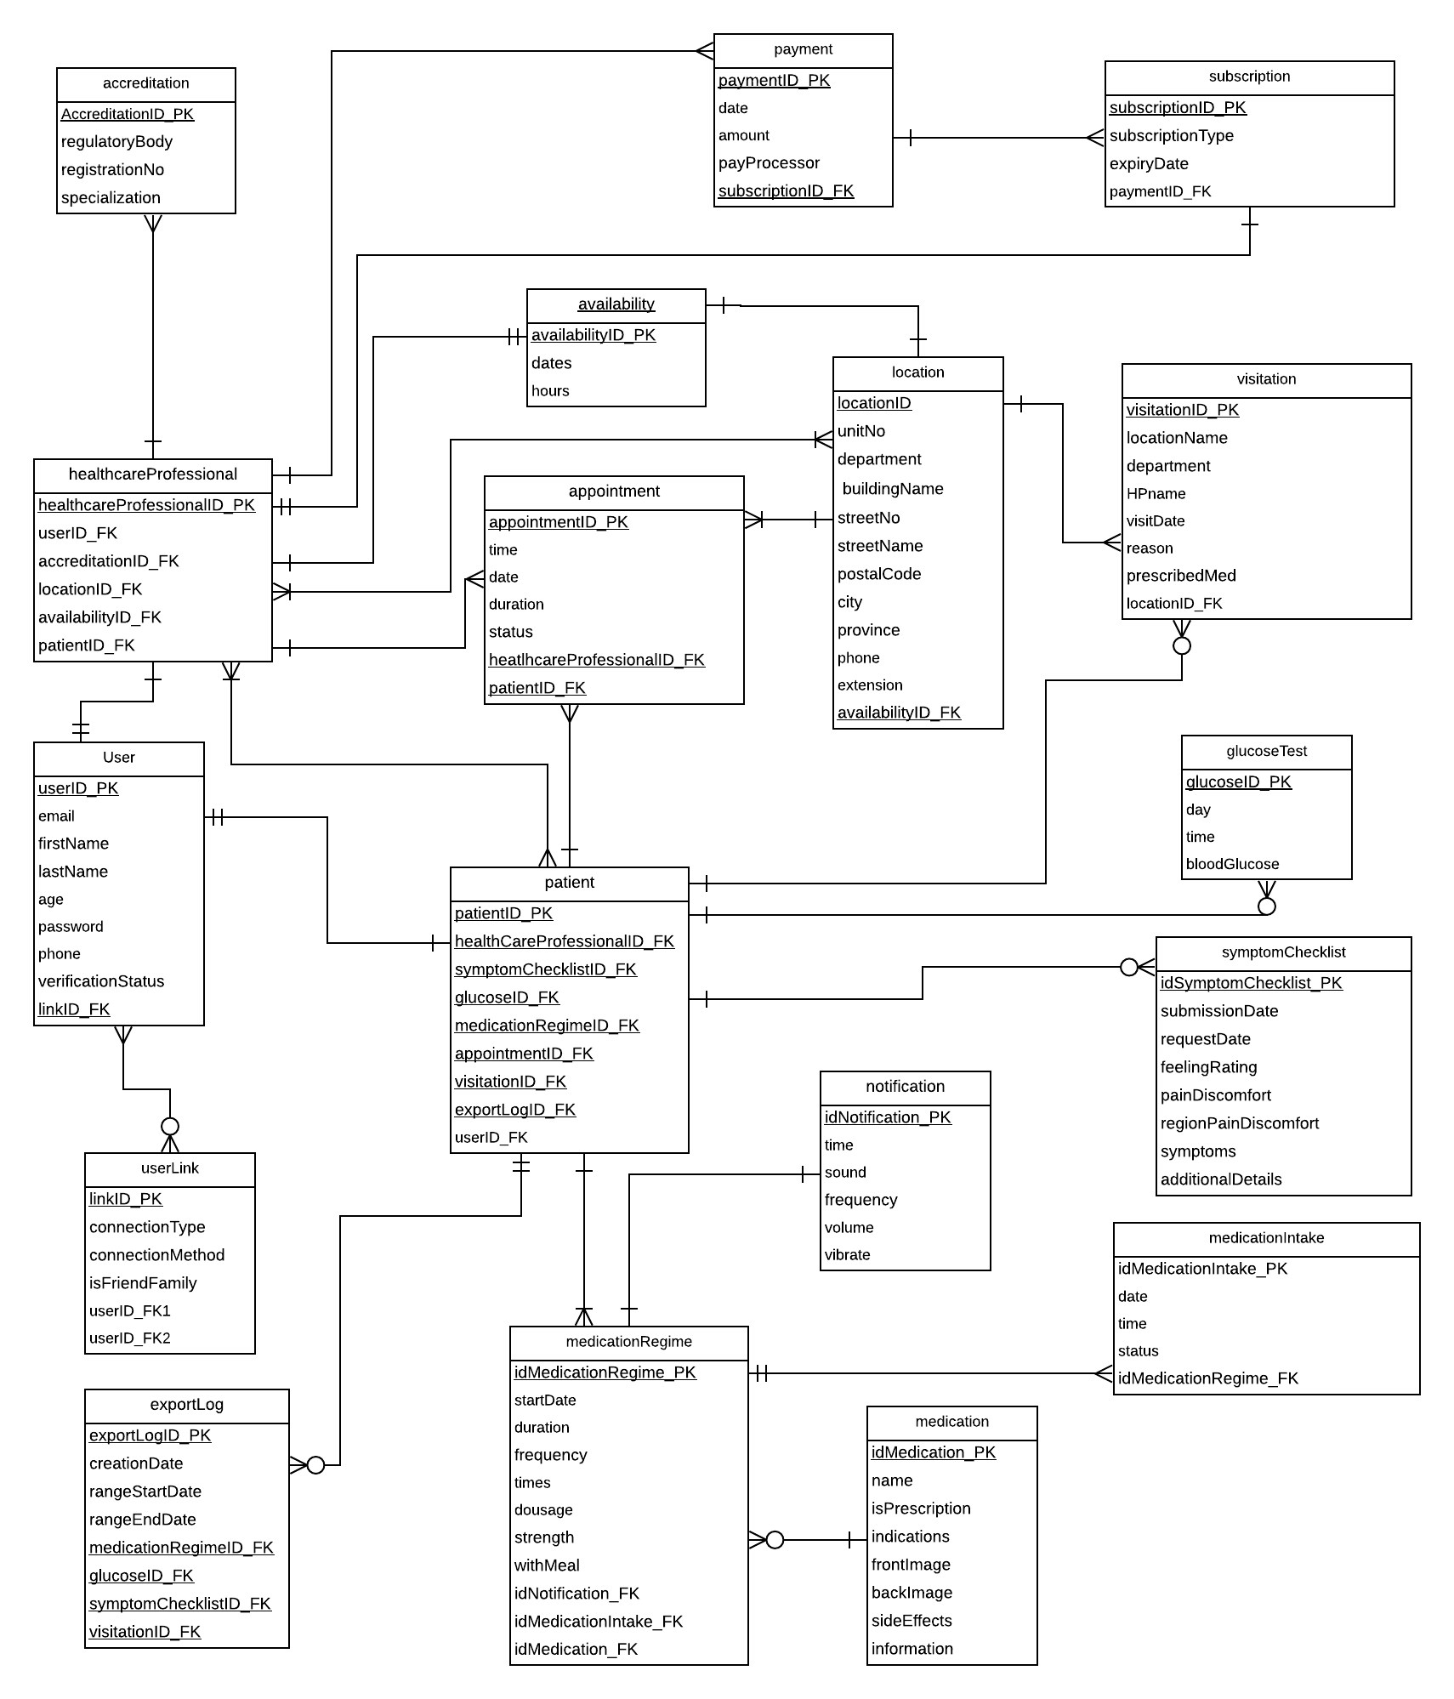

# Implementation Schedule for PRJ666

## Work Breakdown Structure

1.0 Account Management

1.1 Account types

1.1.1 Implement account - Health Professional

1.1.1.1 Implement Health Professional license form

1.1.1.2 Consolidate different accreditation data fields

1.1.1.3 Build table and associations for account type

1.1.1.4 Define Health Professional regulatory body API

1.1.2 Implement account - Patient

1.1.2.1 Build tables, associations and class for account type

1.1.3 Implement account – Friend/Family

1.1.3.1 Build tables, associations and class for account type

1.2 Account creation

1.2.1 Develop account creation interface

1.2.2 Research and choose email verification service

1.2.3 Implement email verification process

1.3 Sign-in system

1.3.1 Develop sign-in interface

1.3.2 Research and choose secure user sign-up, sign-in library/service

1.3.3 Implement secure user sign-up, sign-in

1.4 User-link service

1.4.1 Create methods for data sharing between users

1.4.1.1 Implement permissions for user-links

1.4.2 Implement link menu page

1.4.2.1 Develop link method selection modal

1.4.3 Design connection modes

1.4.3.1 Implement Invitation code link method

1.4.3.2 Implement QR code link method

1.4.3.3 Define link in database

2.0 Medication Information

2.1. General Medication Information (what it's for, photo, name, common name, symptoms)

2.1.1. Implement API Handler for Medication Information database

2.1.1.1 Analyze systems for public drug databases

2.1.1.2 Create application database structure for medication information

2.1.1.3 Define API methods for retrieving Medication information

2.1.2. Develop medication information view

2.1.2.1. Define user interface for medication information

2.1.2.2. Define user interface for possible side-effects

2.1.2.3 Develop button or trigger for symptom checklist

2.2. Patient Medication Information

2.2.1. Implement patient medication information

2.2.1.1. Define user interface which details patient prescription

2.2.2. Database set-up using mySql database

2.2.2.1. Define attributes of patient prescription in database

2.2.2.2. Define methods for creation, modification and deletion

2.2.3. Develop user interface or form to add medication

2.2.3.1. Develop feature to search for OTC medication from open-source API

2.2.3.2. Develop methods to connect to open-source API of OTC medications

2.2.3.3. Develop or implement API to handle medication date time selector

2.2.3.4. Develop form for medication details

2.2.3.5. Implement add new medication button or trigger

2.2.3.6. Develop confirmation modal

2.2.5. Develop option to edit medication

2.2.5.1. Design edit medication form from create medication layout

2.2.5.2. Implement confirmation modal

2.2.6 Develop option to delete medication

2.2.6.1. Implement deletion warning modal

2.2.6.2. Develop deletion notification to health professional

2.3 Medication list view

2.3.1 Create user interface for list of current medications

2.3.2. Add feature for new medication option

3.0 Patient List & Details

3.1. Patient List for Health Professionals

3.1.1. Develop interface for patient list with key attributes

3.2. Patient Details for Health Professionals

3.2.1. Implement dashboard to view patient details

3.2.1.1. Develop view for patient medication adherence

3.2.1.2. Develop view for patient symptom checklist

3.2.1.3. Develop view for patient open prescriptions

3.2.2. Implement interactive dashboard components

3.2.2.1. Develop patient symptom checklist request

4.0 Medication Notification

4.1. Medication Notification Storage

4.1.1. Detail notification attributes in a database

4.1.1.1. Research and select method for local storage

4.1.1.2. Detail notification attributes in database

4.1.2. Implement methods for notification

4.1.2.1. Research and select method for alarm/notification feature

4.1.2.2. Implement alarm and notification interface

4.2. Medication Notification Creation, Deletion, Modification

4.2.1. Implement methods for notification creation

4.2.1.1. Develop methods for notification creation and, modification

4.2.1.2. Develop form for notification creation

4.2.2.2. Link notification creation with medication information

4.2.2. Implement notification modification methods

4.2.2.1. Develop an edit mode for creation layout

4.2.2.2. Develop confirmation modal for saved changes

5.0 Home Page

5.1 Homepage - General

5.1.1 Medication Intake Progress Bar component

5.1.1.1. Develop methods to retrieve number of required medications of a day

5.1.1.2. Develop methods to retrieve number of taken medications of a day

5.1.1.3. Develop progress bar component

5.1.2. Day selector

5.1.2.1. Develop methods to handle date-time

5.1.2.2. Develop interface for date selection

5.1.2.3. Implement change in medication view triggered by date selection

5.1.3. Current date

5.1.3.1. Develop view to display the current date

5.2 Homepage - Health Professional

5.2.1 Display a list of patients currently in treatment

5.2.2 Implement a menu page for Health Professional include patient management functions

6.0 Symptom Checklist

6.1. Symptom Checklist Database

6.1.1. Define attributes for symptom checklist in database

6.1.2. Develop methods for creation of symptom checklist

6.2. Symptom Checklist Form

6.2.2. Develop form for symptom checklist

6.2.3. Develop confirmation modal for completion of symptom checklist

6.3. Symptom Checklist Notification

6.3.1. Develop notifications to health professional after completion of symptom checklist

6.3.2 Develop reminder system for incomplete checklist requests

6.4. Symptom Checklist Sending

6.4.1. Develop a list for user to check their symptoms



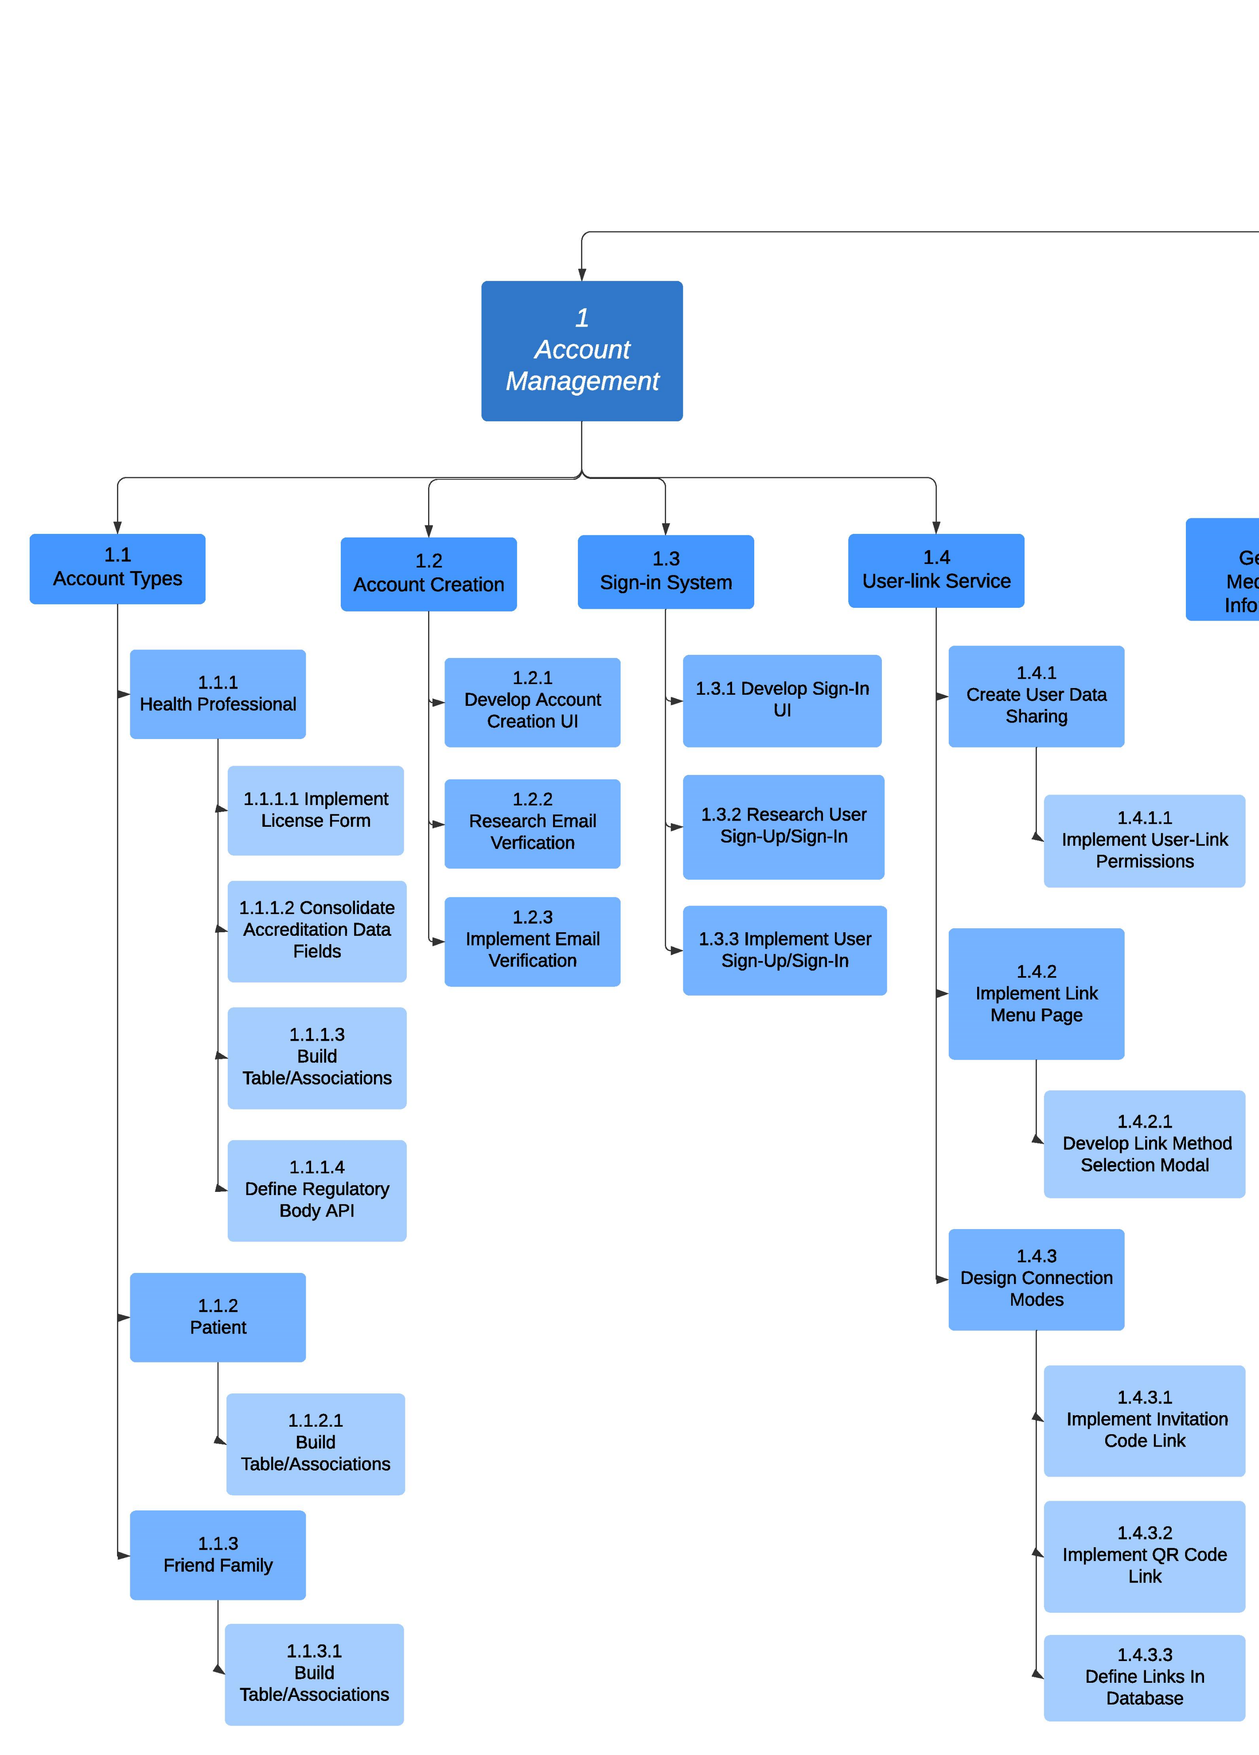

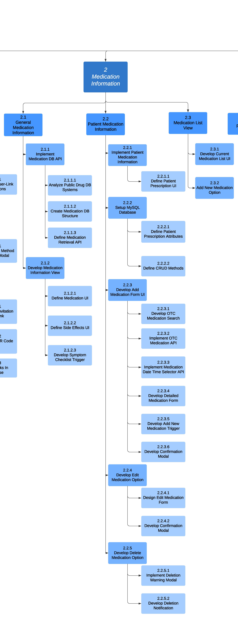

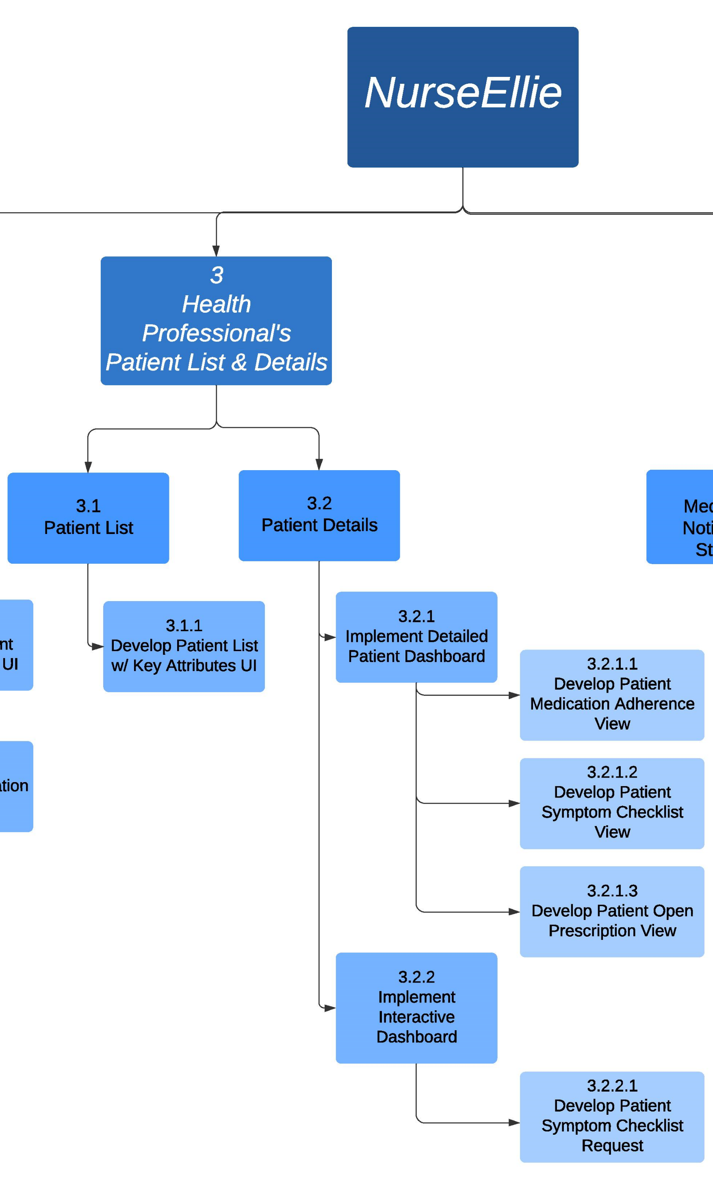

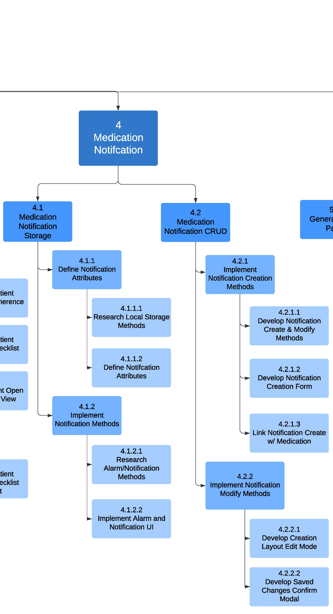

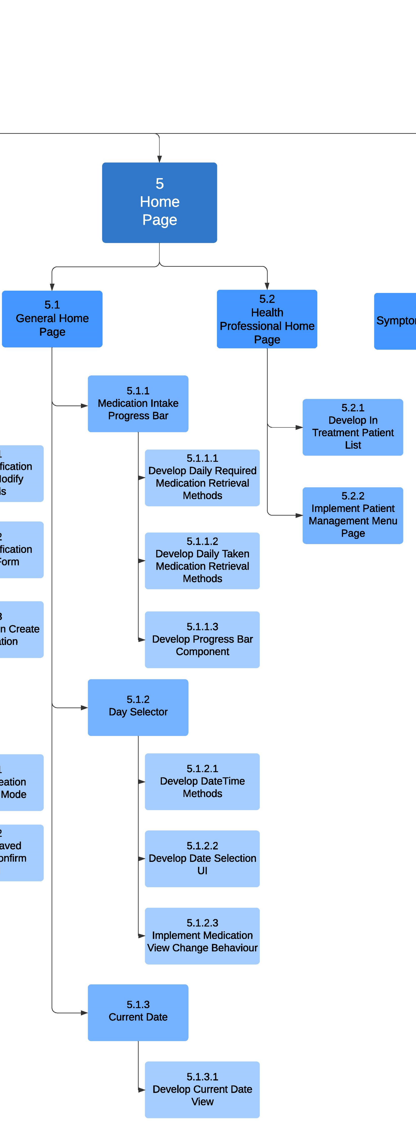

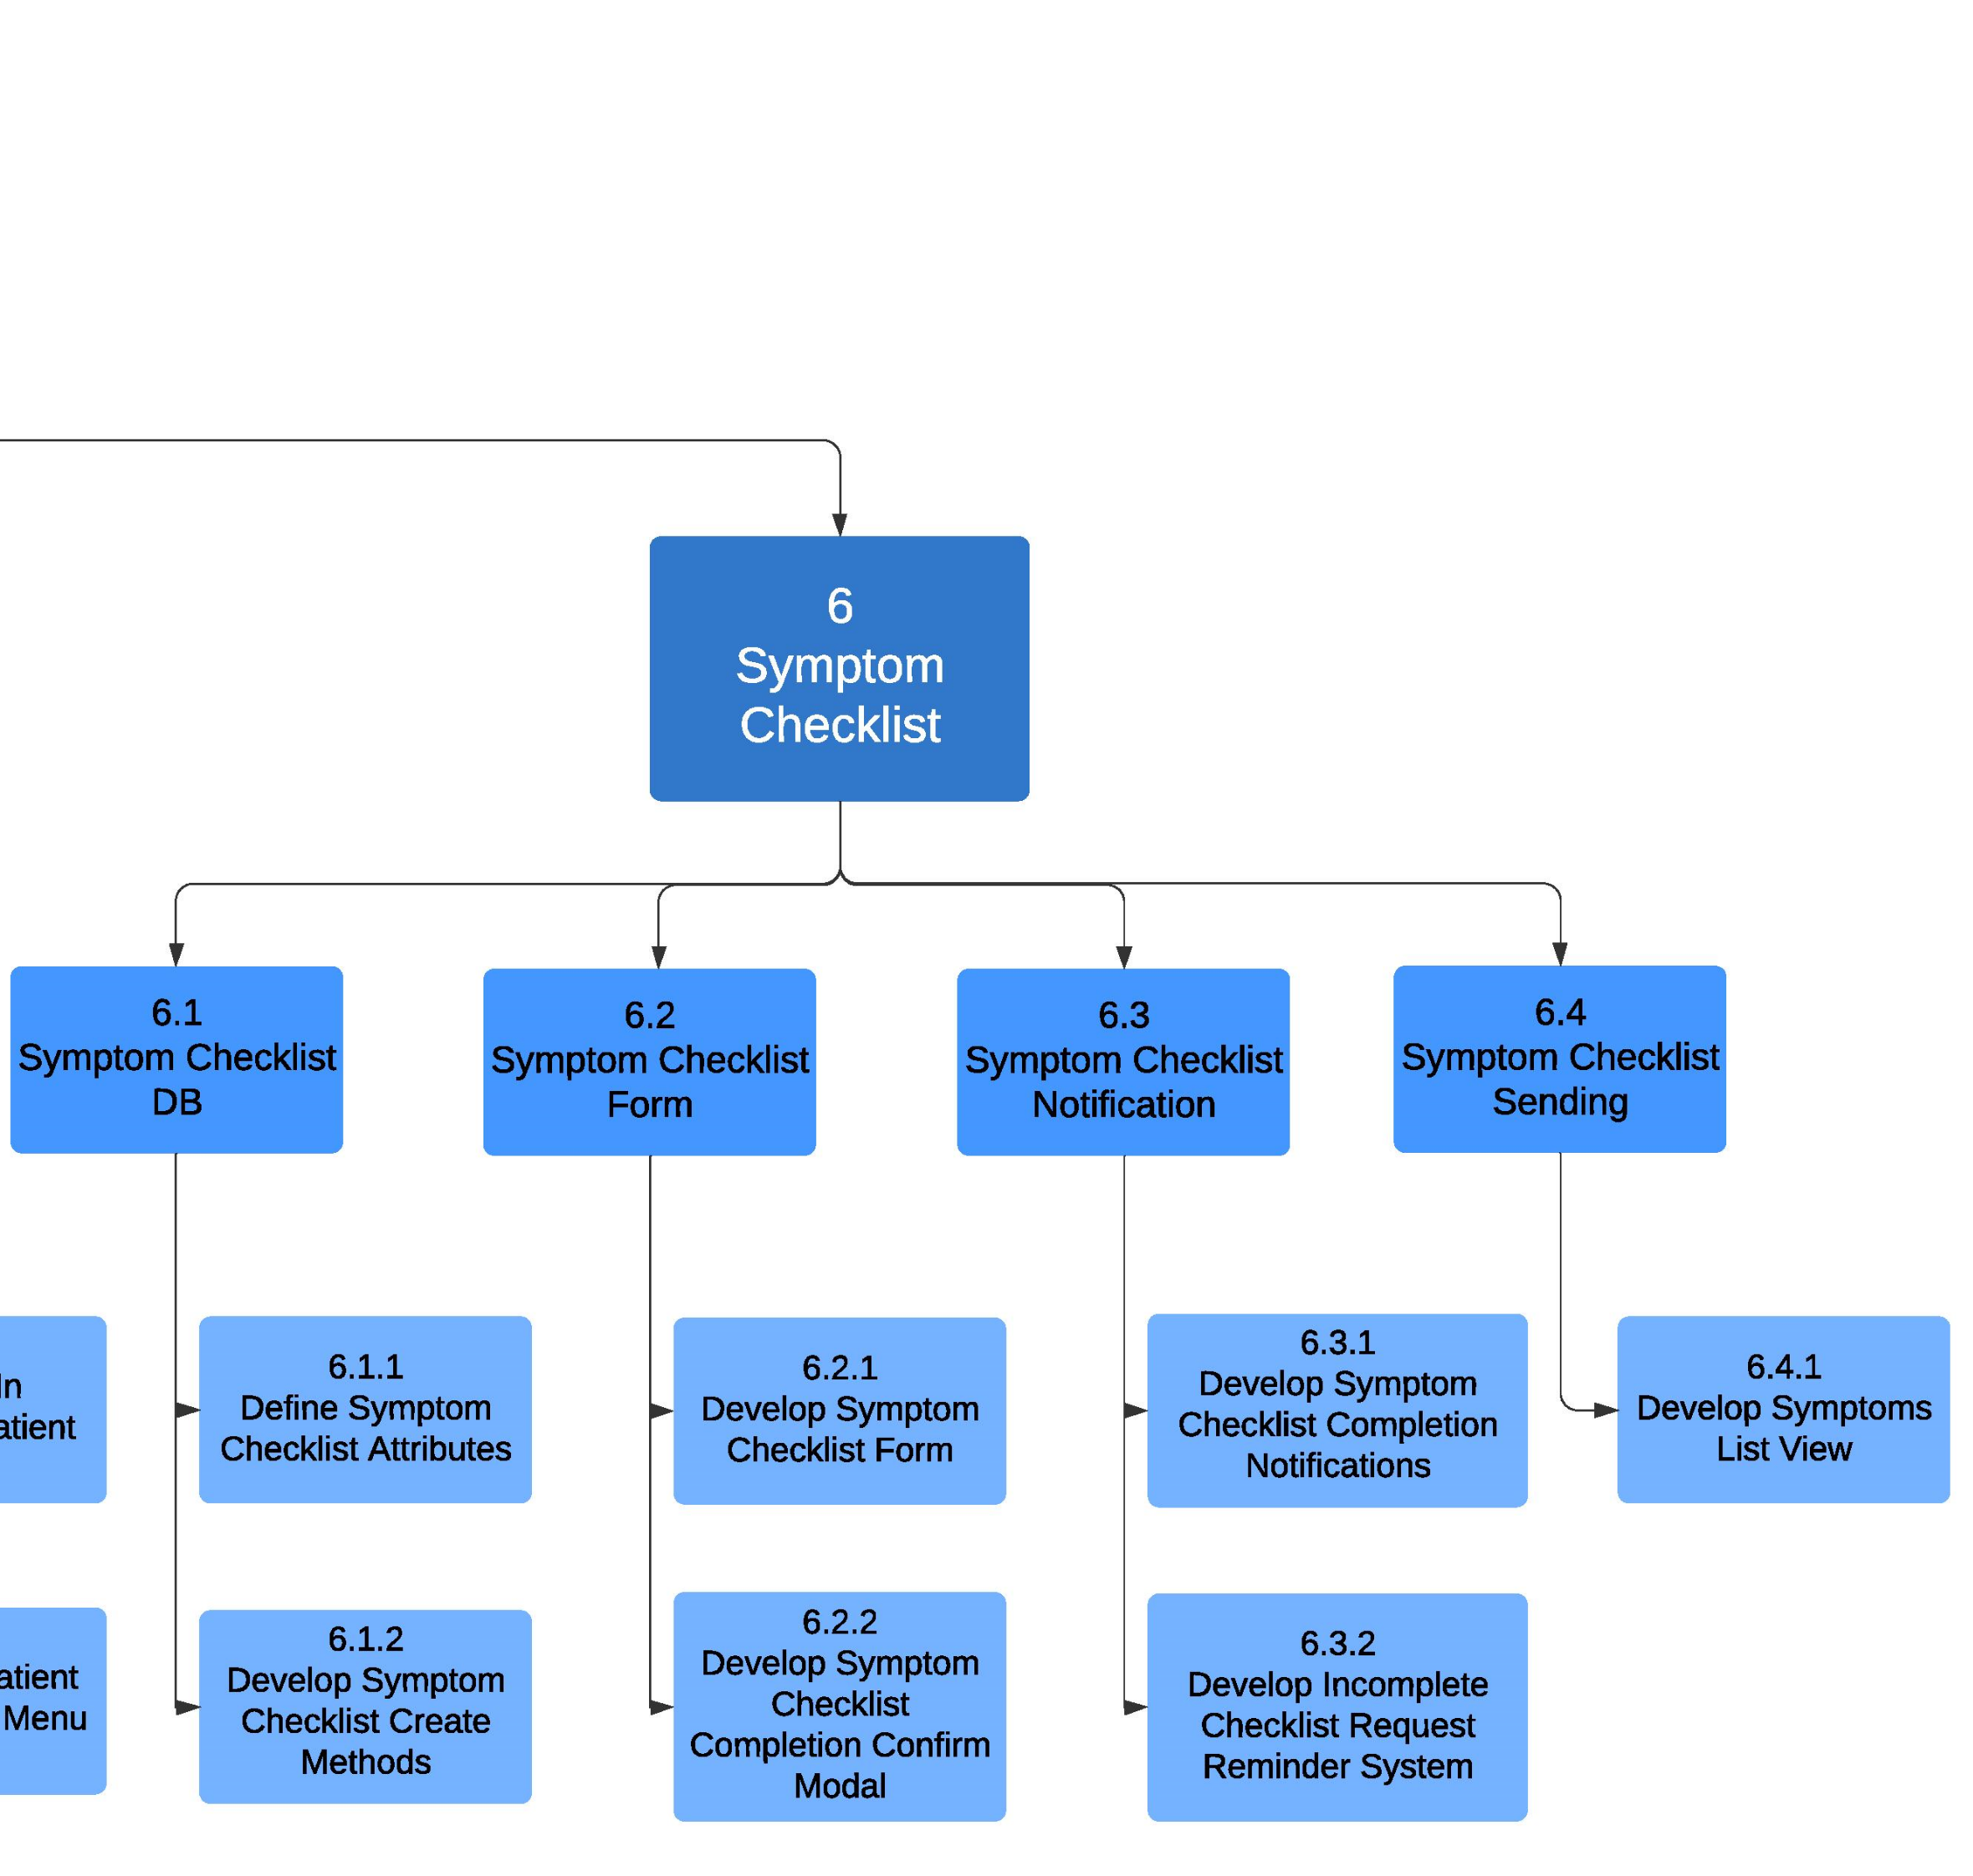

## 5.2 Implementation Schedule using MS Project

|  |  |  |  |
| --- | --- | --- | --- |
| Task Name | Duration | Start | Finish |
| **Nurse-Ellie** | **54 days** | **Mon 9/14/20** | **Fri 12/4/20** |
| Set-up and Proof of Technology | 3 days | Mon 9/14/20 | Wed 9/16/20 |
| **1.0 Account Management** | **15 days** | **Thu 9/17/20** | **Wed 10/7/20** |
| **1.1. Account types** | **6 days** | **Thu 9/17/20** | **Thu 9/24/20** |
| 1.1.1. Implement account - Health Professional | 3 days | Tue 9/22/20 | Thu 9/24/20 |
| 1.1.2. Implement account - Patient | 3 days | Thu 9/17/20 | Mon 9/21/20 |
| 1.1.3. Implement account – Friend/Family | 3 days | Tue 9/22/20 | Thu 9/24/20 |
| 1.2. Account creation | 2 days | Fri 9/25/20 | Mon 9/28/20 |
| 1.3. Sign-in system | 2 days | Tue 9/29/20 | Wed 9/30/20 |
| **1.4. User-link service** | **7 days** | **Tue 9/29/20** | **Wed 10/7/20** |
| 1.4.1. Create methods for data sharing between users | 3 days | Tue 9/29/20 | Thu 10/1/20 |
| 1.4.2. Implement link menu page | 2 days | Fri 10/2/20 | Mon 10/5/20 |
| 1.4.3. Design connection modes | 2 days | Tue 10/6/20 | Wed 10/7/20 |
| **2.0 Medication Information** | **9 days** | **Thu 10/8/20** | **Wed 10/28/20** |
| **2.1. General Medication Information** | **6 days** | **Thu 10/8/20** | **Fri 10/16/20** |
| 2.1.1. Implement API Handler for Medication Information database | 4 days | Thu 10/8/20 | Wed 10/14/20 |
| 2.1.2. Develop medication information view | 2 days | Thu 10/15/20 | Fri 10/16/20 |
| **2.2. Patient Medication Information** | **8 days** | **Thu 10/8/20** | **Tue 10/27/20** |
| 2.2.1. Implement patient medication information | 2 days | Thu 10/8/20 | Fri 10/9/20 |
| 2.2.2. Database set-up using mySql database | 2 days | Tue 10/13/20 | Wed 10/14/20 |
| 2.2.3. Develop user interface or form to add medication | 2 days | Thu 10/15/20 | Fri 10/16/20 |
| 2.2.4. Develop option to edit medication | 2 days | Mon 10/26/20 | Tue 10/27/20 |
| 2.2.5. Develop option to delete medication | 2 days | Mon 10/26/20 | Tue 10/27/20 |
| 2.3. Medication list view | 5 days | Thu 10/15/20 | Wed 10/28/20 |
| **3.0 Patient List and Details** | **4 days** | **Wed 11/11/20** | **Mon 11/16/20** |
| **3.1. Patient List for Health Professionals** | **2 days** | **Wed 11/11/20** | **Thu 11/12/20** |
| 3.1.1. Develop interface for patient list with key attributes | 2 days | Wed 11/11/20 | Thu 11/12/20 |
| **3.2. Patient details for Health Professionals** | **4 days** | **Wed 11/11/20** | **Mon 11/16/20** |
| 3.2.1. Implement dashboard to view patient details | 2 days | Wed 11/11/20 | Thu 11/12/20 |
| 3.2.2. Implement interactive dashboard components | 2 days | Fri 11/13/20 | Mon 11/16/20 |
| **4.0 Medication Notification** | **8 days** | **Tue 11/17/20** | **Thu 11/26/20** |
| **4.1. Medication Notification Storage** | **4 days** | **Tue 11/17/20** | **Fri 11/20/20** |
| 4.1.1. Detail notification attributes in a database | 2 days | Tue 11/17/20 | Wed 11/18/20 |
| 4.1.2. Implement methods for notification | 2 days | Thu 11/19/20 | Fri 11/20/20 |
| **4.2. Medication Notification Creation, Deletion, Modification** | **4 days** | **Mon 11/23/20** | **Thu 11/26/20** |
| 4.2.1. Implement methods for notification creation | 2 days | Mon 11/23/20 | Tue 11/24/20 |
| 4.2.2. Implement notification modification methods | 2 days | Wed 11/25/20 | Thu 11/26/20 |
| **5.0 Home Page** | **36 days** | **Thu 10/8/20** | **Fri 12/4/20** |
| **5.1 Homepage - General** | **6 days** | **Fri 11/27/20** | **Fri 12/4/20** |
| 5.1.1 Medication Intake Progress Bar component | 2 days | Fri 11/27/20 | Mon 11/30/20 |
| 5.1.2. Day selector | 2 days | Tue 12/1/20 | Wed 12/2/20 |
| 5.1.3. Current date | 2 days | Thu 12/3/20 | Fri 12/4/20 |
| **5.2 Homepage - Health Professional** | **4 days** | **Thu 10/8/20** | **Wed 10/14/20** |
| 5.2.1 Display a list of patients currently in treatment | 2 days | Thu 10/8/20 | Fri 10/9/20 |
| 5.2.2 Implement a menu page for Health Professional include patient management functions | 2 days | Tue 10/13/20 | Wed 10/14/20 |
| **6.0 Symptom Checklist** | **10 days** | **Wed 10/28/20** | **Tue 11/10/20** |
| **6.1. Symptom Checklist Database** | **4 days** | **Wed 10/28/20** | **Mon 11/2/20** |
| 6.1.1. Define attributes for symptom checklist in database | 2 days | Wed 10/28/20 | Thu 10/29/20 |
| 6.1.2. Develop methods for creation of symptom checklist | 2 days | Fri 10/30/20 | Mon 11/2/20 |
| **6.2. Symptom Checklist Form** | **4 days** | **Tue 11/3/20** | **Fri 11/6/20** |
| 6.2.2. Develop form for symptom checklist | 2 days | Tue 11/3/20 | Wed 11/4/20 |
| 6.2.3. Develop confirmation modal for completion of symptom checklist | 2 days | Thu 11/5/20 | Fri 11/6/20 |
| **6.3. Symptom Checklist Notification** | **2 days** | **Mon 11/9/20** | **Tue 11/10/20** |
| 6.3.1. Develop notifications to health professional after completion of symptom checklist | 2 days | Mon 11/9/20 | Tue 11/10/20 |
| 6.3.2 Develop reminder system for incomplete checklist requests | 2 days | Mon 11/9/20 | Tue 11/10/20 |
| **6.4. Symptom Checklist Sending** | **2 days** | **Mon 11/9/20** | **Tue 11/10/20** |
| 6.4.1. Develop a list for user to check their symptoms | 2 days | Mon 11/9/20 | Tue 11/10/20 |
| **Weekly Meeting and Integration Testing** | **49 days** | **Wed 9/16/20** | **Wed 12/2/20** |
| **Daily Stand-up Meeting** | **53 days** | **Mon 9/14/20** | **Fri 12/4/20** |

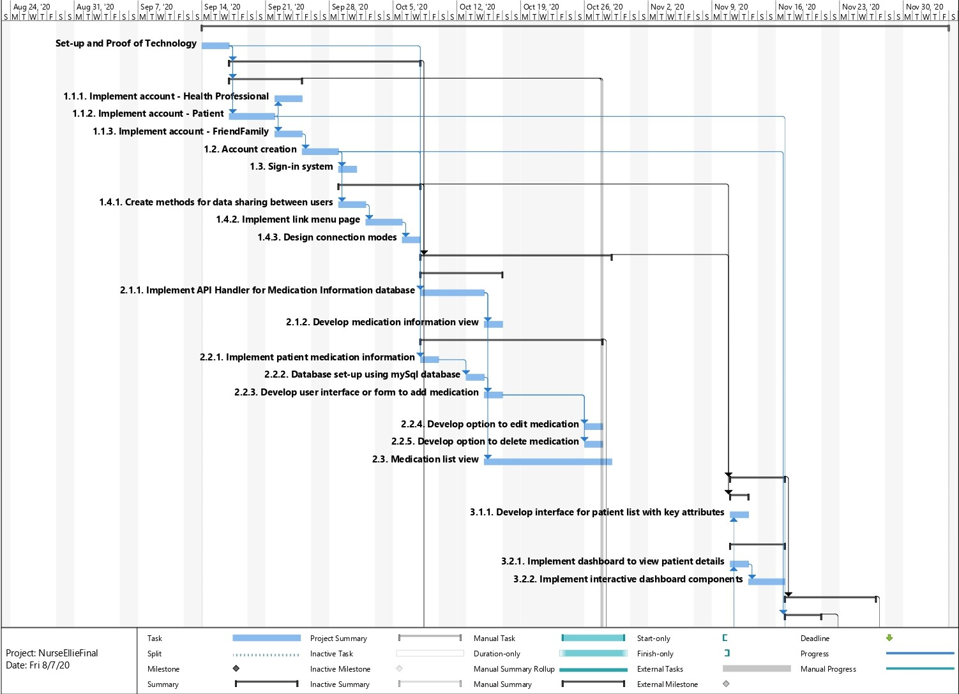

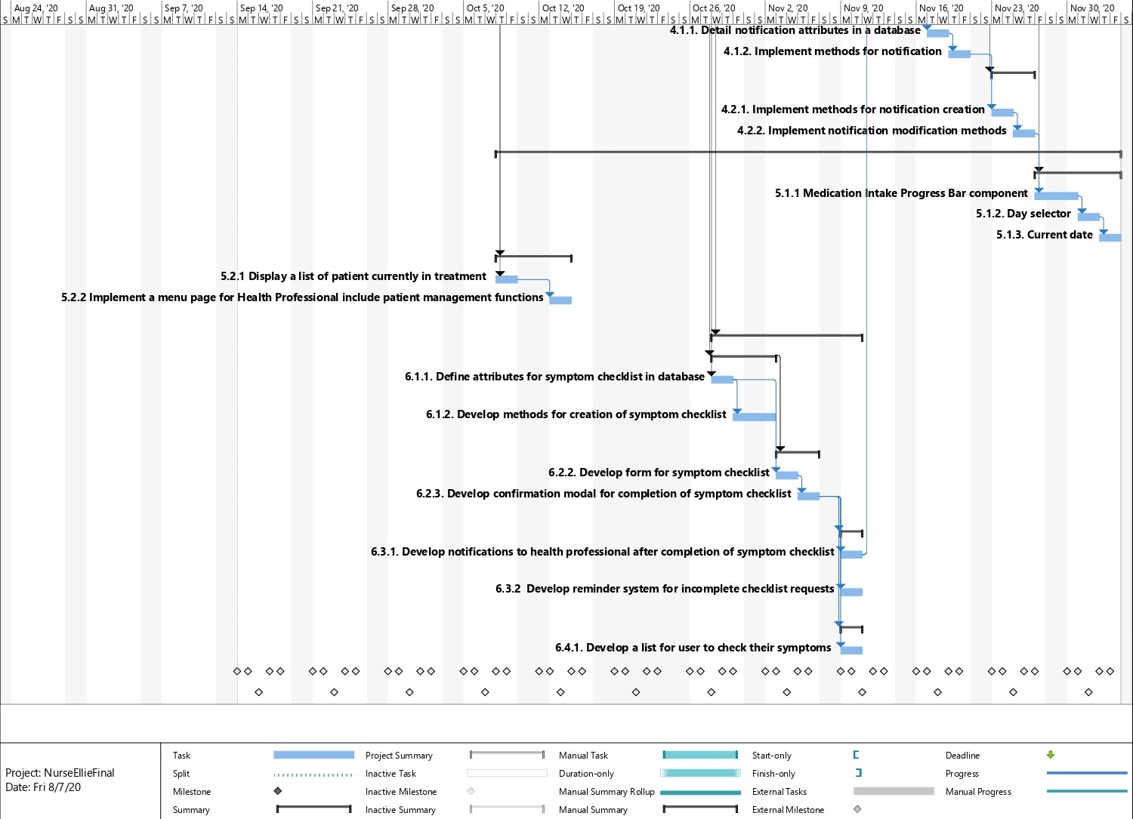

# Measurable deliverables

* Application has account registration and sign in functionalities
* Application runs on Android and iOS
* Patient can customize medication notifications
* Health Professional and Patients can be registered to each other
* Can track medication intake
* Patient feedback is shared with Health Professional and optionally with Friends/Family
* Information on medication

# Acceptance Criteria

* Account creation bounces back if password criteria is not met or a unique email is not provided
* Account verification request is triggered after user submits account information
* Patient can select connection method to connect to Health Professional
* Patient can connect their account to the account of a Family Member or Friend
* Patient is registered to Health Professional after invitation code or QR code is inputted or scanned
* English is a default language
* Patient can have one account only
* User will receive a confirmation email after registered
* User can only register an account by filling in all required fields
* Password must be at least minimum 8 characters, with at least one capital letter and number
* Health Professional can add their specialization and license information to create a Health Professional account
* Health Professional can view a list of their connected Patients
  + Health Professional can view patient detail showing prescription medications and symptom checklists
* Patient can view how many medications are remaining or required for the day
* Patient can view list of current medications showing next scheduled intake for each medication
* Patient can select medication to view general information and intake specification
* Patient can submit a symptom checklist for a current medication that will be shared with registered Health Professional
* Health Professional can request symptom checklist from patient and track it’s completion status
* Patient can take photo image of medication and save it
* Patient can add off-the-counter medications to their medication list
* Patient can edit notifications for medications in their list
* Health Professionals can add, modify, and delete medications for registered Patient accounts
  + Patient will receive warning for modifying or deleting medications set by Health Professional
* Patients can share their medical information with health professionals or friends/family.
  + Shared medical information requires a code to view it
* Notification reminder to take medication will appear on screen
* Medication intake is tracked as taken or not taken when medication notification is dismissed
* Health Professional can make a request for a Patient to complete a Symptom Checklist
* Patient can voluntarily initiate and complete a Symptom Checklist

# Risks and Response

* Course Load and Midterms
  + Probability: High
  + Response(s):
    - Allot one week close to midterms as time off and non-working time
* Holiday/Family Time
  + Probability: High
  + Response(s):
    - Allot one day as non-working time
* Social Loafing
  + Probability: Medium
  + Response(s):
    - If scheduled time for task is exceeded talk it through and ask why it's happening
    - Address teammate’s loafing in daily stand-up meeting
* Sickness/Illness
  + Probability: High
  + Response(s):
    - If someone has tasks they cannot do, teammate can take on workload and sick person will reciprocate.
* Bugs
  + Probability: High
  + Response(s):
    - Use GitHub as version control and always have one teammate assigned to review pull request
    - Help teammates in discord meeting to research and troubleshoot difficult to fix bug together
* Team Conflict
  + Probability: Medium
  + Response(s):
    - Team will take vote on issue and possible resolutions and ‘Milestone’ leader will count as two votes. Solution adopted will have majority support
    - Daily standup will serve as early preventative measure to catch issues before they develop into a serious conflict
* Black Swan Event (Internet not working)
  + Probability: Very Low
  + Response(s)
    - Have most up-to-date copy of project code saved locally and do what you can offline until internet restored.
* Ability
  + Probability: High
  + Response(s):
    - All obligated to research and practice technology before Fall term starts
* Scope Creep
  + Probability: Low
  + Response(s)
    - Team members will point it out in daily meeting if they want to propose new feature or if part of current scope more difficult than anticipated.
    - Help teammates in discord meeting to research and troubleshoot difficult to implement feature together
    - Consult PID as reference to stay within defined scope

# Client / Faculty Sign-off

**Date: ______________________**

X .

Name of Client/Rep/Professor

Company Name